BBSI 2008-2009 Academic Year Proposal
QPCR Analysis of Bacterial DNA Extractions
Annica Stull-Lane
Home Mentor: Taylor Allen
VCU Mentor: Kimberly Jefferson

I. Introduction
Bacterial vaginosis (BV) is the most prevalent vaginal infection in women of reproductive age, with a point prevalence of 8%–23%.¹ Complications associated with BV include preterm delivery, ² an increased risk of pelvic inflammatory disease, ³ and an increased susceptibility to HIV acquisition and transmission. ⁴ Current treatment, which usually involves metronidazole drug therapy, has not proved sufficient. Even after apparently successful treatment, there is still over a 50% recurrence rate. ^{5,6} Despite the rate of recurrence and the prevalence of infection, however, current knowledge of the etiology and pathogenesis of BV is limited. While the initiation factor of BV remains a mystery, it has been associated with three characteristics: a rise in pH (> 4.5), an overgrowth of pathogenic anaerobic bacteria, and a reduction in lactobacilli, the bacteria present in the healthy vagina. Lactobacilli produce lactic acid and hydrogen peroxide, maintaining the low pH of the vagina and, ideally, preventing the BV-associated bacteria from colonizing. If we can characterize how these pathogenic anaerobes can persist to live in the vagina, then perhaps we can develop methods to disrupt their colonization and prevent recurring infections. Of these pathogenic bacteria, Gardnerella vaginalis has been found to be the predominant species. ^{7,8} However, it does not occur on its own, as there are many other anaerobic bacteria associated with BV, including Atopobium vaginae, Prevotella bivia, and Mobiluncus vaginalis. Of all bacteria identified, only G. vaginalis is known to produce a very resilient biofilm. ⁷ A biofilm is an adherent community of microorganisms surrounded by a protective slime and complex matrix of polysaccharides, proteins, and/or nucleic acids. ^{3,10} Some biofilm communities, like dental plaque, involve a very specific succession of bacterial adherence: the later colonizers depend on the earlier colonizers for adherence and growth in an otherwise unsuitable environment. ⁹ If the community of anaerobes present in BV develops through species succession and G. vaginalis is the initial colonizer, then one might think it would help secondary colonizers adhere and grow in an otherwise unsuitable environment.
My initial hypothesis this summer includes two parts: 1) G. vaginalis is the initial colonizer in bacterial vaginosis, and 2) The G. vaginalis biofilm creates a suitable environment for other BV-associated anaerobes to adhere to the vaginal epithelium and survive in the presence of chemicals present in the vagina, such as oxygen, lactic acid, and hydrogen peroxide.

II. Progress Report

To begin testing this hypothesis, I collected preliminary results from two experiments: an adherence assay and a growth assay. These are two aspects important to the formation of biofilms. The aims of these assays were to test if G. vaginalis, a facultative anaerobe, aided the adherence and growth of other anaerobic bacteria associated with BV. The bacteria used in these experiments with G. vaginalis were the obligate anaerobes Prevotella bivia, Mobiluncus mulieris, and Atopobium vaginae.

Methods: Adherence with Confocal Microscopy
For the adherence assay, the first step was to visualize bacterial adherence to ME180 vaginal epithelial cells (ATCC, Manassas, VA) using confocal laser-scanning microscopy. The bacteria were stained with a BacLight Green bacterial stain (Invitrogen, Carlsbad, CA) and the epithelial cells were stained with Vibrant Red cell membrane stain (Invitrogen). After staining, the plates were centrifuged to maximize contact between the bacteria and epithelial cells, incubated for 30 minutes at 37°C to allow adherence, and washed with phosphate buffered saline (PBS) to remove the nonadherent bacterial cells. The cells were visualized by confocal microscopy using a Zeiss Multiphoton microscope, excitation wavelengths of 488nm and 541nm and a 63X dipping objective.

Results:
The qualitative visual results showed that G. vaginalis adhered very well, clumping around the epithelial cells (Figure 1b). P. bivia and A. vaginae did not adhere as well, as no bacterial cells could be visually detected in the image (Figure 1c & 1d). Interestingly enough, though, M. mulieris did seem to adhere very strongly as well, as the rod-shaped bacteria also stuck to the epithelial cells (Figure 1e).

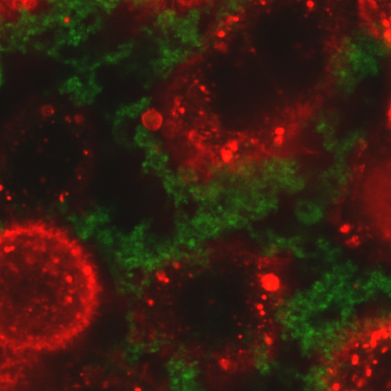
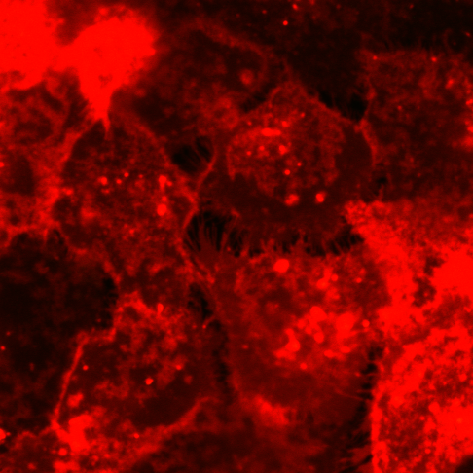
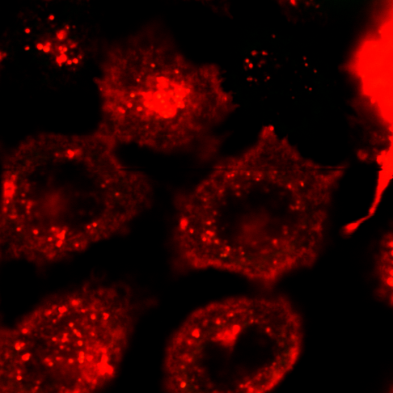
G. vaginalis
Control
P. bivia

1a. 1b. 1c.

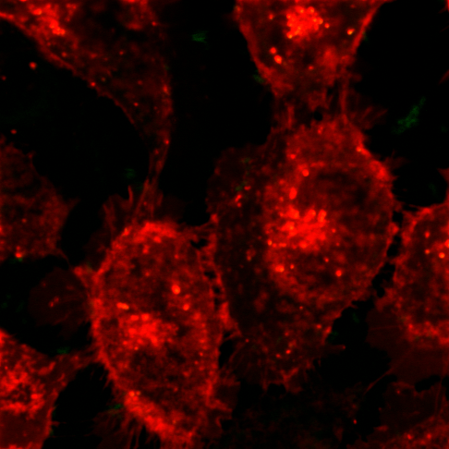
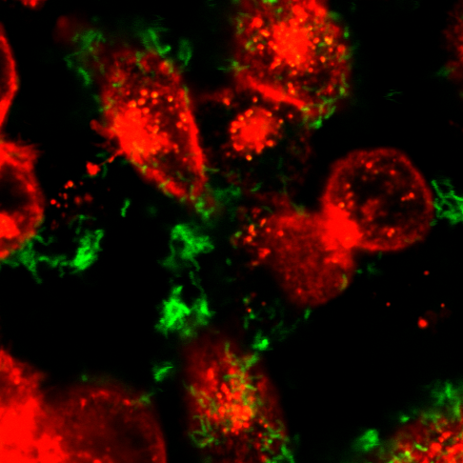
A. vaginae
M. mulieris

1d. 1e.
[Figure 1: Adherence of anaerobic bacteria to ME180 vaginal epithelial cells]

Methods: Adherence in Co-Culture and qPCR
The next step of adherence was to test whether the presence of G. vaginalis aided the adherence of the three anaerobes. This assay has been done for both P. bivia and M. mulieris, but not for A. vaginae yet since it was not growing optimally at the time of the experiment. First, ME180 vaginal epithelial cells were grown on 6-well plates. Next, G. vaginalis was centrifuged onto two wells of the epithelial cells and allowed to adhere for 30 minutes at 37°C. Then, an anaerobe was centrifuged on two wells of only epithelial cells as well as the two wells with epithelial cells and G. vaginalis. Another incubation of 30 minutes at 37°C followed, and all wells were then washed with PBS to remove nonadherent bacteria. Measuring relative adherence would be difficult visually via confocal microscopy because the different bacterial species can not be easily distinguished microscopically; thus, quantitative real-time polymerase chain reaction (qPCR) with SYBR Green was used. In regular PCR, DNA template is amplified exponentially. In qPCR, this reaction is also measured after each amplification cycle by monitoring the fluorescence. SYBR Green is a fluorescent dye that binds to double-stranded DNA, and the measure of its fluorescence corresponds to the amount of DNA amplified. Eventually the DNA amount and fluorescence will reach a threshold after a given number of cycles. This cycle threshold value can be related to the amount of original DNA template. Taking the logarithmic scale into account, these values can help relatively compare DNA samples. To acquire these DNA from the adherence assay, the wells received lysis buffer and were scraped into tubes. The DNA was extracted using the DNeasy Tissue Kit (Qiagen, Valencia, CA). Then, the extracted DNA was analyzed by qPCR in order to determine relative amounts of DNA (i.e. relative amount of adherence). Species-specific 16s rRNA primers were used to differentiate between bacteria strains, and it was also tested that the primers only amplified the correct bacterial species DNA.
Statistical significance was conducted using an online Student’s t-test (http://www.physics.csbsju.edu/stats/t-test_bulk_form.html).

Results:
There was a nearly 2-fold decrease in the amount of M. mulieris DNA in wells containing both G. vaginalis and M. mulieris vs M. mulieris alone. The data was statistically significant with a p-value of 0.027. Similarly, slightly less than twice as much P. bivia DNA was extracted from the wells of only P. bivia than from the wells with both G. vaginalis and P. bivia. The data was statistically significant with a p-value of 0.022.

Methods: Growth in Anaerobic and Aerobic Conditions
To test if a G. vaginalis biofilm aided growth of other anaerobes associated with BV, the following steps were taken with each of the three anaerobes in both aerobic and anaerobic conditions. First, a G. vaginalis biofilm was grown on a 6-well plate for 24 hours at 37°C. Then the anaerobe culture was added to two wells of the biofilm. At the same time, the anaerobe culture was also added to two wells of an empty 6-well plate. Both plates were allowed to grow at 37°C from 3 to 5 days, and the media was exchanged each day. The plates were centrifuged and washed with PBS. DNA from the wells was extracted for qPCR analysis with the Qiagen DNeasy Kit. Statistical significance on the qPCR data was conducted using the online Student’s t-test mentioned above.

Results:
Each anaerobe had different results. In both aerobic and anaerobic conditions, M. mulieris had twice the extracted DNA from the M. mulieris only wells than the wells with the G. vaginalis biofilm and M. mulieris. More DNA overall was extracted from the anaerobic conditions, but the relative difference of growth was similar in both conditions. This was statistically significant data with p-values of 0.0002 for aerobic and 0.0003 for anaerobic.
Aerobically, P. bivia had more than twice as much DNA extracted from the biofilm and anaerobe wells than from the only anaerobe wells. In contrast, aerobic conditions yielded 27 times as much DNA from the anaerobe only wells than the biofilm and anaerobe wells (Figure 2). This was statistically significant data with a p-value of 0.0001 for both aerobic and anaerobic.
The results from the A. vaginae growth assay were not statistically significant, with p-values of 0.44 for aerobic and 0.62 for anaerobic. The error bars were very large, as the data points were variable. The trend of growth was similar to P. bivia, with more DNA with the biofilm aerobically and more DNA with the anaerobe only anaerobically.
p=0.0001
p=0.0001

[Figure 2: P. bivia growth]

III. Academic Year: Goals and Plans

This academic year I will have four aims:

Aim 1: Continued qPCR analysis of growth and adherence assays
Before I left Virginia Commonwealth University (VCU), I extracted DNA from assays and I will be using the qPCR cycler available at Oberlin College through Marta Laskowski to obtain more data for statistical analysis. The Jefferson Lab will FedEx these DNA samples and the species-specific primers for my use at my home academic institution. Since the data gained from this summer were very preliminary, it is necessary to analyze more samples and determine if they support the initial trends seen from this summer.

Aim 2: Correlating colony-forming units with cycle threshold values
In order to correlate numbers of bacteria with qPCR threshold counts for the growth and adherence assays, we plated initial inocula to obtain colony-forming unit (CFU) counts. From the CFU’s, one can extrapolate back to determine how many bacterial cells were initially used and determine if growth occurred or not. The CFU’s were recorded at VCU and the DNA from these bacterial standards will be shipped to Oberlin. Thus, this school year I will be running qPCR on known inoculations in order to correlate bacterial numbers with a qPCR cycle threshold value. I will do this for each bacterial organism used in the experiments. With the data from this test, I will be able to convert all of my previous real-time qPCR data into meaningful, quantitative numbers that represent bacterial counts.

Aim 3: Calculate qPCR efficiency
Since much of this project is using qPCR, it is important to test how efficient the primers are in the amplification of the 16SrRNA gene. To do this, I will do serial 2-fold dilutions of DNA template, using the DNA extracted from the CFU-counted bacteria from aim 2. In qPCR, the DNA should double with each cycle. Thus, if there is a 1 cycle increase with each successive dilution, it is at 100% efficiency. If there is a greater than 1 cycle increase, then there is less than 100% efficiency. If there is less than a 1 cycle increase, then there is a greater than 100% efficiency, meaning there may be non-specific products. The qPCR efficiency calculations will help me determine how reliable my qPCR data are.

Aim 4: Literature search to replicate physiological conditions of the vagina
Even though the adherence and growth assays overall seemed not to support the initial hypothesis, there are still other factors to consider. In other words, the hypothesis that G. vaginalis is an initial colonizer that creates a more suitable environment for anaerobe growth and adherence may be true in other, more physiologically relevant conditions. P. bivia growth and the effect of G. vaginalis on this growth was condition-dependent. It is also important to acknowledge that the assays above were in vitro experiments, and they certainly did not emulate all of the physiological vaginal conditions. To prepare for next summer and the additional adherence and growth assays, I will be conducting a literature search to learn more about vaginal environment, brainstorming ways to replicate it physiologically. One idea is instead of growing the bacteria in their optimal media, brain-heart-infusion with glucose (BHIG), grow them instead in a chemically defined medium (CDM) that simulates genital tract secretions. ¹¹ I would also like to find the oxygen content in the vagina, perhaps an average amount since it probably varies with the menstrual cycle. There are other factors associated with BV that may be replicable in the lab, such as local immune function, loss of lactobacilli, and a rise in pH. One example of replicating the natural vaginal conditions is the continued feeding of the biofilm. Feeding, or removing old media and replacing with new media, removes nonadherent cells similarly to the constant mucus flow over the epithelial wall in the vagina. This article research will not only increase my understanding of the vaginal environment, but also help me brainstorm ways to replicate it in order to conduct assays under more relevant conditions.

IV. Budget
Possible expenses:
SYBR Green (Quantace, Norwood, MA): $374.00
FedEx samples: $15.00 per shipment, $45.00 total
Travel to conference, possibly: $900.00 (estimate)
V. References

      - Marrazzo, JM. A Persistent(ly) Enigmatic Ecological Mystery: Bacterial Vaginosis. J Infect Dis 2006;193:1475-7.

      - Simhan HN, Caritis SN, Krohn MA, Hillier SL. The vaginal inflammatory milieu and the risk of early premature preterm rupture of membranes. Am J Obstet Gynecol 2005;192:213-8.

      - Patterson JL, Girerd PH, Karjane NW, Jefferson KK. Effect of biofilm phenotype on resistance of Garderella vaginalis to hydrogen peroxide and lactic acid. Am J Obstet Gynecol 2007;197:170.e1-170.e7.

      - Shin LY, Kaul R. Stay it with flora: maintaining vaginal health as a possible avenue for prevention of human immunodeficiency virus acquisition. J Infect Dis 2008;197.10:1355-7.

      - Wilson J. Managing recurrent bacterial vaginosis. Sex Transm Infect 2004;80:8-11.

      - Bradshaw CS, Morton AN, Hocking J, Garland SM, Morris MB, Moss LM, Horvath LB, Kuzevska I, Fairley CK. High recurrence rates of bacterial vaginosis over the course of 12 months after oral metronidazole therapy and factors associated with recurrence. J Infect Dis 2006;193:1478-86.

      - Swidsinski A, Mendling W, Loening-Baucke V, Ladhoff A, Swidsinski S, Hale LP, Lochs H. Adherent biofilms in bacterial vaginosis. Obstet Gynecol 2005;106.5;1012 23.

      - Swidsinski A, Mendling W, Loening-Baucke V, Swidsinski S, Dorffel Y, Scholze J, Lochs H, Verstraelen H. An adherent Gardnerella vaginalis biofilm persists on the vaginal epithelium after standard therapy with oral metronidazole. Am J Obstet Gynecol 2008;198:97-99.

      - Marsh PD, Bradshaw DJ. Dental plaque as a biofilm. J Indust Microbiol 1995;15.3:169-175.

      - Monroe D. Looking for chinks in the armor of bacterial biofilms. PLoS Biology 2007;5.11:2458-61.

      - Geshnizgani AM, Onderdonk AB. Defined Medium Simulating Genital Tract Secretions for Growth of Vaginal Microflora. J Clin Microbiol 1992;30.5:1323-26.

