Identification of cis-acting regulatory elements within the genome of Cryptosporidium hominis: Application to glycolysis

Eric Wilson
Summer 2006 Final Report
VCU BBSI Summer Institute

Abstract:
Genome sequencing technology today is faster, more reliable and more cost effective than ever before. However, sequencing alone is insufficient to answer complex biological issues. As such, there has been increasing demand for technologies and techniques that can extract useful information from genomic data. In this investigation, we applied a series of Gibbs sampling algorithms to the newly genome of Cryptosporidium hominis, a disease-causing parasite related to Plasmodium falciparum, in an effort to locate cis-acting regulatory elements in the glycolysis pathway. Such regulatory elements represent likely drug targets for future therapies. A promising putative regulatory element was discovered by several of the algorithms used and a series of microarrays were run to establish coregulation among the glycolysis genes. However, much work is still required to confirm this discovery.

Introduction:

Genomic sequencing today is faster, more reliable and more efficient than when the technology first became available. However, more and more, scientists are realizing the limits of sequencing techniques for tackling complex biological problems. It is not enough to be able to sequence a piece of DNA. The real goal is to understand the meaning of that sequence as it applies to the organism as a whole. Because of this, there has been increasing demand in recent years for the development of bioinformatic techniques that can extract useful information from genomic data. One particular area of scientific interest has been in the detection of cis-acting regulatory elements. These overrepresented sequences control gene regulation at the molecular level which in turn governs the way organisms respond to environmental changes macroscopically.
There are a number of methods available for locating cis-acting regulatory elements. One of the most popular and established bioinformatic tools for the detection of regulatory elements is the use of algorithms that utilize Gibbs sampling. Gibbs sampling is an iterative method for the detection of putative regulatory elements. The algorithm begins by randomly selecting a number of sites among the genetic input sequences and calculating a number called a MAP score. MAP stands for maximum a priori and the magnitude of the MAP score is representative of the degree of similarity between the aligned sequences at the various sites. A greater MAP score is indicative of greater sequence similarity. After the initial seeding, a Gibbs sampling algorithm attempts to improve the MAP score by modifying the number, location and length of the site sequences. A Gibbs sampling algorithm continues this process through many iterations until it reaches a maximum MAP score. The detected sequence corresponding to this MAP score is a putative regulatory element. The maximum MAP score determined for any given run depends largely on the initial site selection. Because of this, running the algorithm multiple times does not necessarily result in the same putative regulatory element. Many trials are necessary to locate the most promising regulatory elements using Gibbs sampling.
Cryptosporidium hominis is an obligate intracellular parasite related to Plasmodium falciparum, the parasite responsible for malaria. A member of the phylum apicomplexa, C. hominis uses a sophisticated structure called an apical complex to penetrate host cell defenses. The parasite has a very complex life cycle, consisting of multiple sexual and asexual phases (figure 1). It is spread through the fecal oral route. New infections occur when hosts ingest water contaminated by Cryptosporidium oocysts.

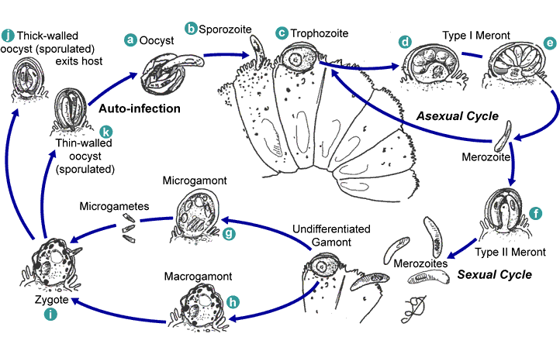
Figure 1: This image depicts the various life cycle stages of Cryptosporidium hominis. Infection begins with the oocyst phase, which is ingested by the host. The chemical environment of the intestine stimulates the parasite to excyst as a sporozoite. The sporozoite then attaches itself to the epithelial cells of the small intestine, eventually becoming a meront. The life cycle continues with asexual as well as sexual reproduction which eventually results in the production of oocysts which are released into the external environment with the host’s feces.

Infection by C. hominis results in a diarrheal disease called cryptosporidiosis. This disease causes great discomfort in the immunocompetent but its effects are rarely lasting. Symptoms include cramps, nausea, diarrhea, dehydration and fever. These symptoms last between one and two weeks. For the immunocompromised, the disease can be fatal. Because of the difficulty of purifying water contaminated by cryptosporidium oocysts, the parasite constitutes a real threat to the health and welfare of populations around the world. As such, it has been classified as a bioterrorist agent. The lack of viable treatments for this disease is both a world health and national security concern.
The genome of Cryptosporidium hominis was recently sequenced by the Buck lab at the Center for the Study of Biological Complexity and likely genes were located and annotated. However, very little is known about this organism. This study details a series of experiments aimed at discovering cis-acting regulatory elements in the genome of C. hominis. Cis-acting elements are regions of the DNA sequence with a high affinity for binding promoter proteins. Bound promoter proteins increase gene expression by inducing the transcription of mRNA. Sets of genes with the same regulatory sequence in their upstream regions are said to be coregulated because expression of all genes would be activated by the introduction of a specific promoter protein. The overarching goal of this line of research is the creation of new drug therapies to combat cryptosporidiosis. The hope is that elucidation of cis-acting regulatory elements will lead to discovery of their associated proteins. Because of their powerful affect on metabolic activity, promoter proteins represent promising targets for future pharmaceuticals.

Methods/Discussion:

Since the glycolysis pathway has been shown to be coregulated in previous studies on Drosophila melanogaster and Saccharomyces cerevisiae, 13 genes associated with the glycolysis pathway were chosen: Chro.80199- Alcohol dehydrogenase, Chro.70063- L-lactate dehydrogenase, Chro.60434- Glyceraldehyde 3-phosphate dehydrogenase, Chro.40087- Pyruvate dehydrogenase, Chro.60435- Hexokinase, Chro.20231- 6-phosphofructokinase, Chro.10234- Pyruvate kinase, Chro.70113- Phosphoglycerate kinase, Chro.70488- Acylphosphatase, Chro.70351- Pyruvate decarboxylase, Chro.10335- Fructose-bisphosphate aldolase, Chro.50184- Phosphopyruvate hydratase, Chro.10337- Triosephosphate isomerase, Chro.20336- Glucose-6-phosphate isomerase, Chro.10196- Phosphoglycerate mutase, Chro.20343- Phosphoglucomutase, Chro.10418- Acetate--CoA ligase. Since, previous literature indicated that two hundred base pairs constituted a reasonable length, sequences up to two hundred base pairs upstream of the translational start points were extracted from the BioBIKE Parasite Edition server In the case of closely adjacent upstream genes, the entire intergenic region was extracted. The average sequence length was 142 with a low of 51 and a high of 200.
These sequences were then rewritten in FASTA format and subjected to a variety of Gibbs-sampling algorithms including MEME, AlignACE, SeSiMCMC and others. The analysis were repeated a total of ten times for each of the programs, yielding a number of putative regulatory motifs. The sequence from each program receiving the highest MAP score was considered represented the most likely regulatory elements identified by that particular program.
The top scoring motifs for each of the three Gibbs-sampling algorithms, MEME, AlignACE and SeSiMCMC are displayed below as weblogos (figure 2).

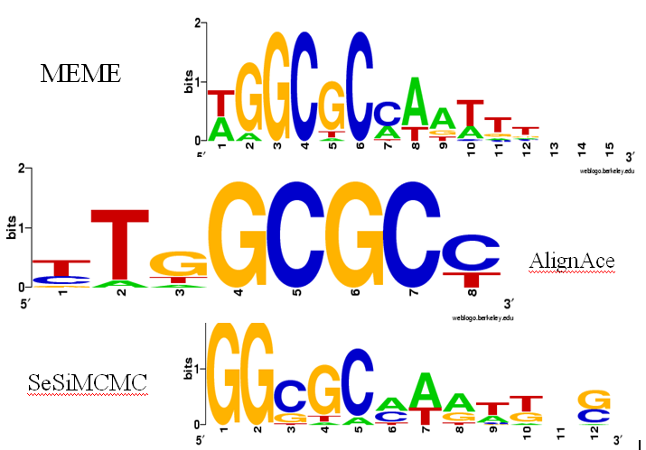
Figure 2: This figure represents the greatest scoring motifs for each of three Gibbs sampling programs. Though each motif is slightly different, there is significant overlap between them. They are aligned to emphasize their similarities. Each of these motifs is visualized using Weblogo. The height of the letters is related to information content.

Although each of the programs yielded different results, there are significant areas of overlap. Many programs identified the same regions in the different input sequences. The motifs detected by the different programs showed significant overlap.

AGCAGAAATTTGGCGCCAATTTAGCCCGA

AGCAGAAATTTGGCGCCAATTTAGCCCGA

AGCAGAAATTTGGCGCCAATTTAGCCCGA

Figure 2: Part of one of the sequences used for analysis. It is from the upstream region of the gene Chro.60434 which is believed to be responsible for the synthesis of Glyceraldehyde 3-phosphate dehydrogenase. The colored regions of the sequence represent the maximum-scoring motifs generated by the three programs. The motif discovered by MEME is displayed first, followed by AlignACE and SeSiMCMC. There is significant overlap in the regions detected by the different algorithms.

The three top-scoring motifs from the three different programs can be combined into single, more significant motif (figure 3).

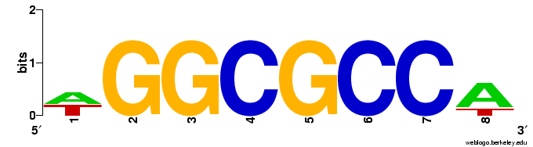
Figure 3: This represents the consolidated motif from the three Gibbs Sampling programs. Once again, the greater height of the letters represents greater information content. The motif is eight base pairs long and is pallindromic. This represents the most significantly conserved sequence among the sequences upstream of the glycolysis genes of C. hominis.

The motif displayed in figure three represents the most likely putative regulatory element in the sequences upstream of the glycolysis genes of C. hominis based on purely bioinformatics methods. In order to confirm or refute the validity of this regulatory element, it was necessary to perform real-world wet-lab analysis. It was first necessary to confirm that the genes associated with glycolysis are in fact coregulated in C. hominis. To accomplish this, a series of microarray experiments were performed.
Oocyst and sporozoite life cycle phases were used for the microarray experiments because of the vastly different energy requirements of the sporozoite and the oocyst. We believed that, because of the much greater energy requirements of the sporozoite phase, we would find upregulation in the genes associated with glycolysis. Myrna Serrano had previously isolated and purified RNA from oocysts as well as sporozoites at 0, 20, 40 and 60 minutes after excystation. The purified RNA was used to run the microarray experiments for each of the categories. A replicate was also run.
At this point, we ran out of time. Analysis of the microarray slides is still pending, but it is expected to show upregulated glycolysis genes in the sporozoite phase as compared to the oocyst. This would provide at least preliminary evidence of coregulation. However, the degree of upregulation will have to be examined quantitatively through PCR techniques and further wet lab analysis must be done before any substantive conclusions can be made about coregulation in the glycolysis pathway.
Although, it would be impossible to reach any significant conclusion without further investigation, the microarray slides will give us a clue as to which direction to proceed. If they show upregulation of the glycolysis pathway in the sporozoite phase, we will need to proceed to more quantitative analyses using RT-PCR. RT-PCR would reveal with greater clarity the extent of upregulation and would allow us to compare quantitatively the magnitude of upregulation among the various genes in the glycolysis pathway. Replicate analyses should also be performed with the microarrays both to confirm the previous results and to enhance their statistical significance.

References

Abrahamsen, Templeton, Enomoto, Abrahante, Zhu, Lancto, Deng, Lui, Widmer, Tzipori, Buck, Xum
Bankier, Dear, Konfortov, Spriggs, Iyer, Anantharaman, Aravind, Kapur. Complete Genome Sequence of the Apicomplexan, Cryptosporidium parvum. Science 304 (2004) 441-445.

Lawrence, C. E., Altschul, S. F., Boguski, M. S., Liu, J. S., Neuwald, A. F. & Wootton, J. C. (1993).
Detecting subtle sequence signals: a Gibbs sampling strategy for multiple alignment. Science, 262, 208-214.

MacIsaac, Fraenkel (2006). Practical Strategies for Discovering Regulatory DNA Sequence Motifs. PloS
Comp. Biol. 2(4e36): 0201-0210.

Schneider, T. D. & Stephens, R. M. (1990). Sequence logos: a new way to display consensus sequence.
Nucl. Acids Res. 18, 6097-6100.

Tavazoie, S., Hughes, J. D., Campbell, M. J., Cho, R. J. & Church, G. M. (1999). Systematic determination
of genetic network architecture. Nature Genet. 22, 1-5.

van Helden, J., Andre, B. & Collado-Vides, J. (1998). Extracting regulatory sites from the upstream
region of yeast genes by computational analysis of oligonucleotide frequencies. J. Mol. Biol. 281, 827-842.

Xu, Widmer, Wang, Ozaki, Alves, Serrano, Puiu, Manque, Akiyoshi, Mackey, Pearson, Dear, Bankier,
Peterson, Abrahamsen, Kapur, Tzipori, Buck (2004). The Genome of Cryptosporidium hominis. Nature. 431: 1107-1112.

