A Comparison in MAO-B Inhibition Between
2,3,6-Trimethyl-1,4-naphthoquinone (TMN) and 8-(3-Chlorostyryl)-caffeine (CSC)

Mark Delboy

11 August 2004

Abstract

Parkinson’s disease is characterized by disabling movements which are caused by the loss of dopaminergic neurons. A preferred drug would prevent the degradation of these neurons and stop further progression into later stages of the disease (Petzer et. al 2003). In MPTP model of Parkinson’s disease, MPTP is metabolized by MAO-B into a neurotoxin which causes the loss of dopamine neurons. A preferred drug would inhibit the formation of the neurotoxin and thus prevent the neuron degradation. Caffeine has been studied as one inhibitor of MAO-B and has lead to the discovery of the inhibitor 8-(3-chlorostyryl)-caffeine (CSC). A lowered activity of MAO-B and lowered incidence of Parkinson’s disease in smokers has sparked interest in searching for inhibitors in tobacco. Such searches for inhibitors has led to the discovery of the inhibitor 2,3,6-trimethyl-1,4-naphthoquinone (TMN) (Castagnoli 2004). Our study was designed to examine the variations in inhibition of various species (for beef, dog, rat, baboon, and monkey liver and human MAO-B and MAO-A homogenates) using TMN and CSC. From the experiments, the various species were found to have K_{i}’s for TMN from 5.4 µM to 10.3 µM while for CSC the K_{i}’s were found from 44 nM to 84 nM. The information obtained from the current study is useful for gaining better understanding of MAO-B inhibition, potentially leading to new drugs that can effectively treat Parkinson’s disease.

Article Outline

1. Introduction
2. Background
2.1. MPTP Model
2.2. 2,3,6-Trimethyl-1,4-naphthoquinone and 8-(3-Chlorostyryl)- caffeine
3. Methods
4. Results
4.1. 8-(3-Chlorostyryl)-caffeine
4.2. 2,3,6-Trimethyl-1,4-naphthoquinone
5. Discussion
Acknowledgements
References

1. Introduction

Currently in the United States, an estimated 500,000 people currently suffer from Parkinson's disease. About 50,000 individuals are expected to be found with the disease next year as the average age of the population increases (NINDS 2001). Parkinson’s disease typically appears around the age of 60 with symptoms of reduced facial expression, softer tone of voice, slow movements, having an inability to move, stooped posture, and rigid limbs (NINDS 2001). Parkinson’s disease involves the loss of neurons that use dopamine as their neurotransmitter resulting in these disabling movement conditions (Petzer et. al 2003). One of the current methods for the treatment of the Parkinson’s involves dopamine replacement therapy with aims of restoring dopaminergic neurons that were lost (Petzer et. al 2003). The treatment is highly favorable for the symptoms of the early stages of Parkinson’s disease but the effectiveness of the treatment method diminishes with time (Petzer et. al 2003). A preferred drug would prevent the degradation of the dopaminergic neurons and stop further progression into later stages of the disease (Petzer et. al 2003). The purpose of the present study was to determine the differences in the amount of inhibition of the MAO-B enzyme in various species using 2,3,6-trimethyl-1,4-naphthoquinone and 8-(3-chlorostyryl)-caffeine (Figure 1) potentially leading to new drugs that can effectively treat Parkinson’s disease.

I II

Figure 1: 8-(3-chlorostyryl)-caffeine (I). 2,3,6-trimethyl-1,4-naphthoquinone (II).

2. Background

2.1. MPTP Model

Studies that have been aimed at developing drugs that are neuroprotective or have improved therapeutic results have led to an MPTP model that suggests one possible origin of Parkinson’s disease. The MPTP model focuses on the chemical reactions associated with the neutrotoxin 1-methyl-4-phenyl-1,2,3,6 tetrahydropyridine (MPTP) (Petzer et. al 2003). The toxic effects of MPTP actually result from the metabolite MPP⁺. MPP⁺ is produced by monoamine oxidase B (MAO-B), Figure 2, an enzyme involved in redox reactions in neural mitochondrial outer membranes (Castagnoli et. al 2001.). The enzyme oxidizes MPTP into MPDP⁺ and produces MPP⁺ with a second oxidation step (Petzer et. al 2003). MPP⁺ is produced by MAO-B in the astrocytes of the brain and is taken into dopaminergic neurons by dopamine transporters (Castagnoli 2004). The neurotoxin accumulates in the mitochondria and inhibits the complex I of the cellular process of respiration (Castagnoli 2004). With the loss of energy resources, cell death commonly occurs (Castagnoli 2004). In the model, with the increase of MPP⁺ neurotoxin, there is a sequential loss of dopaminergic neurons. Although the model is limited by its dependence on MAO-B, the model has led to development of successful and useful drugs such as Eldeprenyl and Selegiline.

I II

Figure 2: The substrate MPTP (I) is catalytically oxidized by the MAO-B enzyme to the dihydropyridinium species (II).

2.2. 2,3,6-Trimethyl-1,4-naphthoquinone and 8-(3-Chlorostyryl)-caffeine

Research has shown that caffeine intake can reduce dopaminergic neural toxicity in MPTP models for Parkinson’s. As a result of these studies, 8-(3-chlorostyryl)-caffeine (CSC) has been found to have neuroprotective properties. The prevention of bioactivation of MPTP involves a competitive inhibition between CSC and the MPTP neurotoxin for human MAO-B.
More recently, researchers have found that tobacco smokers have a lowered amount of MAO-B activity in blood platelets and the brain (Castagnoli 2004). Along with reduced activity, smokers have also been found to have a lower incidence of Parkinson’s disease in comparison to non-smokers (Castagnoli 2004). The correlation has led researchers to identify possible relationships between MAO activity, smoking and Parkinson’s disease (Castagnoli 2004). Norman et al. found a dose dependent inverse relationship for tobacco smoke and the activity of human platelet MAO-B (Norman 1987). Studies using positron emission tomography (PET) allowed researchers to find a 40% reduction in activities of MAO-B in the human brain (Fowler et al. 1996b.) With these convincing results suggesting a relationship between smoking and lowered MAO activities, many researchers have focused their attention on MAO inhibitors in the components of tobacco using the mouse MPTP model. Since DNA studies imply that mammals contain more or less the same number of genes and similar genes, if there is neural protection of mice in the MPTP model from a compound then there should also be neural protective properties in humans from that same compound. Carr and Basham found that treating mice with MPTP chronically and treating with (S)-nicotine, 4-phenylpyridine or hydrazine led to no neural protective properties (1991). Castagnoli et al. established that a reversible MAO inhibitor isolated from tobacco, 2,3,6-trimethyl-1,4-naphthoquinone (TMN), is a neural protective agent in a mouse MPTP model (2001).

3. Methods

Beef liver, baboon liver, rat liver, monkey liver, dog liver mitochondrial homogenate MAO-B, platelet rich plasma-human MAO-B and human placental MAO-A enzyme were all obtained from Castagnoli’s lab for the CSC and TMN studies. Beef liver mitochondrial homogenate MAO-B was also obtained from Edmondson’s lab for the CSC studies. Human liver MAO-B enzyme was obtained from Gentest for the TMN studies.
The substrate, 1-methyl-4-(-1-methyl-2-pyrrolyl)-1,2,3,6,-tetrahydropyridine oxalate salt (N-Me-Pyrr), is catalytically oxidized by the MAO-B enzymes to the dihydropyridinium species (MPP⁺), the latter being chemically stable and detectable at 420 nm. By measuring the absorbance at 420 nm the amount of enzyme activity on the substrate can be determined.
For all experiments, once the solutions were made and placed in the Eppendorf tubes, they were prewarmed for 15 minutes. After 15 minutes, an initial protein concentration of 3 mg/mL was added. The solution was then incubated for 30 additional minutes. After the incubation time, 20 or 40 μL of 70% perchloric acid was added to each solution to stop the reaction. The final solution was centrifuged for 8 minutes on the 16 g or 16,200 rpm setting. The absorbances of the resulting supernatants were then read at 420 nm.
For the CSC inhibition experiments, the samples were placed in Eppendorf tubes with concentrations of 0 nM, 25 nM, 50 nM, 75 nM, 100 nM, and 500 nM CSC. Each concentration of CSC had 0 μM, 15 μM, 30 μM, 45 μM, and 60 μM substrate concentrations added. A listing of the solution compositions for the CSC inhibitions studies are shown in Table 1. Specifically, for 0 nM, 50 nM, and 75 nM CSC samples, 335 μL, 425 μL, 395 μL, 380 μL, and 335 μL of 7.4 pH NaPi buffer was first added to blank, 15 μM, 30 μM, 45 μM, and 60 μM substrate concentrations. Then 120, 30, 60, 75, 120 μL of substrate was added to all of the CSC samples for the blank, 15 μM, 30 μM, 45 μM, and 60 μM substrate concentrations. For the 0 nM CSC, 20 μL of DMSO was added to 15 μM, 30 μM, 45 μM, and 60 μM substrate concentrations while in the 50 nM and 75 nM CSC had 20 μL DSMO added to only the blank sample. With the 50 nM and 75 nM CSC samples, 20 μL of the appropriate CSC solution was added to each of the blank, 15 μM, 30 μM, 45 μM, and 60 μM substrate concentrations to make the 50 nM and 75 nM CSC while in the 0 nM CSC, CSC was not added. 25 μL of Glycerol 7.4 pH NaPi buffer was added to the blank species in 0 nM CSC, 50 nM and 75 nM CSC samples. For 25 nM, 100 nM and 500 nM CSC samples, 335 μL, 435 μL, 405 μL, 390 μL, and 345 μL μL of 7.4 pH NaPi buffer was first added to the appropriate tubes. Then 120, 30, 60, 75, 120 μL of substrate was added to all of the CSC samples for the blank, 15 μM, 30 μM, 45 μM, and 60 μM substrate concentrations. For the 25 nM, 100 nM and 500 nM CSC samples, 10 μL of DMSO was added to the blank samples. Then 10 μL of CSC solution was added to each of 15 μM, 30 μM, 45 μM, and 60 μM substrate concentrations to make the 25 nM, 100 nM, and 500 nM CSC. 25 μL glycerol 7.4 pH NaPi buffer was added to all CSC samples in the blank samples. The protein was added, after prewarming with 25 μL to each of the 15 μM, 30 μM, 45 μM, and 60 μM substrate concentrations for all CSC samples.

Table 1: CSC Assay Method

For TMN experiments, the samples were prepared with concentrations of 0 μM, 2 μM, 4 μM, 6 μM, and 8 μM TMN. Each concentration of TMN had a blank, 15 μM, 30 μM, 45 μM, and 60 μM of substrate added. A listing of the solution compositions for the TMN inhibitions studies are shown in Table 2. Specifically, the substrate concentrations were prepared by first adding 670 μL, 850 μL, 790 μL, 760 μL, and 670 μL of 7.4 pH NaPi buffer to the appropriate tubes. Then 240, 60, 120, 150, 240 μL of substrate was added to all of the TMN samples. For the 0 μM TMN samples, 40 μL of DMSO was added to each of blank, 15 μM, 30 μM, 45 μM, and 60 μM substrate concentrations. 40 μL of the appropriate TMN solution was added to each of the 15 μM, 30 μM, 45 μM, and 60 μM substrate concentrations. 50 μL of glycerol 7.4 pH NaPi buffer was added to the blank. 50 μL of protein was added to each of the samples, excluding the blanks, after prewarming for 15 minutes.

Table 2: TMN Assay Method

A Beckman UV-Vis spectrophotometer, was used for the CSC studies and a single beam was used so a blank was zeroed and read before every group of samples. A Varian UV-Vis spectrophotometer was used for the TMN studies and a double beam was used so two blanks were zeroed and used to create a baseline before samples were zeroed and read.
A Matlab program named kinetic_ss, created in Professor Rutan’s lab, was used to perform a nonlinear regression of the data to the equation below, to find the K_{i} values (Sanchez 2004).

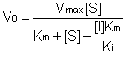
4. Results

4.1 8-(3-chlorostyryl)-caffeine

The inhibitory potential of CSC against beef liver mitochondrial homogenate (obtained from Edmondson’s lab (Edmondson et al. 2002)) MAO-B enzyme activity at various concentrations of 50 nM, 100 nM, 200 nM, 500 nM, 1000 nM, 2000 nM, 5000 nM, 10,000 nM, 20,000 nM, 30,000 nM, and 40,000 nM was tested. The results suggested that CSC has no inhibition at the tested concentration against beef liver mitochondrial MAO-B activity.
The inhibitory potential of CSC against beef liver mitochondrial homogenate (available in Castagnoli’s lab) MAO-B enzyme activity at the concentrations of 50 nM and 100 nM was tested. The results suggested that CSC has no inhibition against beef liver mitochondrial MAO-B activity.
The inhibitory potential of CSC against platelet rich plasma-human MAO-B enzyme activity at concentrations of 400 nM and 800 nM was tested. The results suggested that CSC has an average inhibition of 41.2% at the tested concentration against platelet rich plasma-human MAO-B activity. From the experiment, Figure 3, platelet rich plasma-human MAO-B enzyme was found to have a K_{i} value of 60 ± 24 nM.
________________________________________________________________________

Figure 3: In the figure, the points represent the experimental measurements while the curves represent the fit the predicted data.
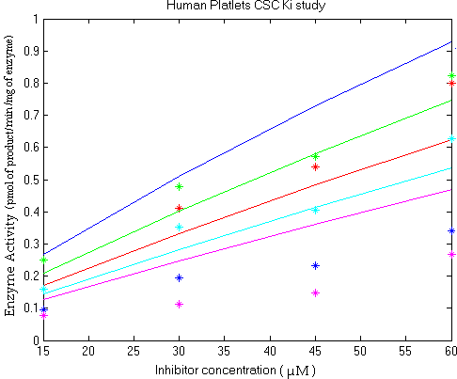________________________________________________________________________

The inhibitory potential of CSC against baboon liver mitochondrial homogenate MAO-B enzyme activity at a concentration of 100 nM was tested. The results suggested that CSC has an average inhibition of 32.5% on the tested concentration against baboon liver mitochondrial MAO-B activity. From other trials, Figures 4-5, baboon liver mitochondrial enzyme was found to have an average K_{i} value of 84 ± 32 nM.
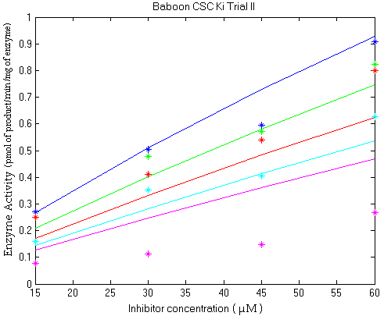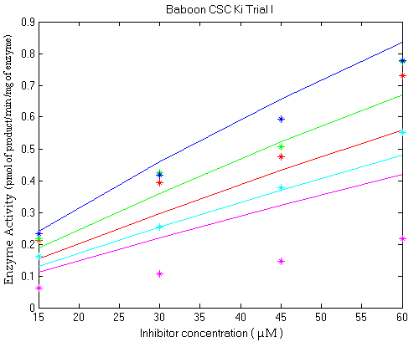________________________________________________________________________
Figure 4: Figure 5:
In these figures, the points represent the experimental measurements while the curves represent the fit the predicted data.
________________________________________________________________________

The inhibitory potential of CSC against monkey liver MAO-B enzyme activity at a concentration of 200 µM was tested. The results suggested that CSC has an average inhibition of 59.0 % at the tested concentration against monkey liver MAO-B enzyme activity. From the trials, Figures 6-8, monkey liver MAO-B enzyme was found to have an K_{i} value of 44 ± 20 nM.
________________________________________________________________________
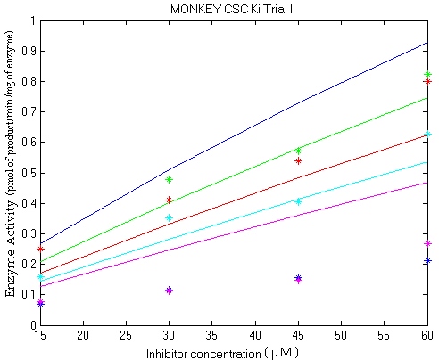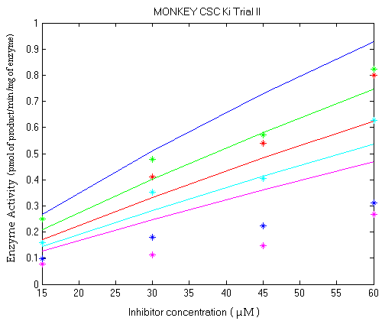 Figure 6: Figure 7:

Figure 8:

In these figures, the points represent the experimental measurements while the curves represent the fit the predicted data.
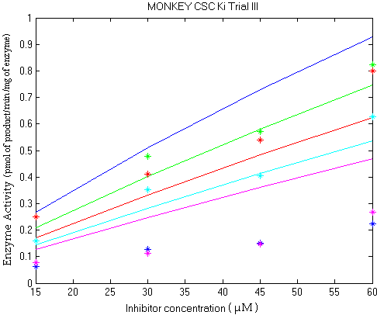_______________________________________________________________________

The inhibitory potential of CSC against rat liver MAO-B enzyme activity at a concentration of 200 µM was tested. The results suggested that CSC has no inhibition on the tested concentration against rat liver MAO-B enzyme activity.
The inhibitory potential of CSC against dog liver MAO-B enzyme activity at a concentration of 200 µM was tested. The results suggested that CSC has an average inhibition of 24.3 % on the tested concentration against dog liver MAO-B enzyme activity.
The inhibitory potential of CSC against human placental MAO-A enzyme activity at various concentrations of: 50 µM, 100 µM, and 200 µM was tested. The results suggested that CSC has no inhibition on the tested concentration against human placental MAO-A activity.

4.2 2,3,6-Trimethyl-1,4-naphthoquinone

The inhibitory potential of TMN against dog liver MAO-B enzyme activity at concentrations of 0 µM, 2 µM, 4 µM, and 8 µM was tested. From the experimental results, Figure 9, dog liver MAO-B enzyme was found to have an average K_{i} value of 9.7 ± 1.8 µM.
________________________________________________________________________
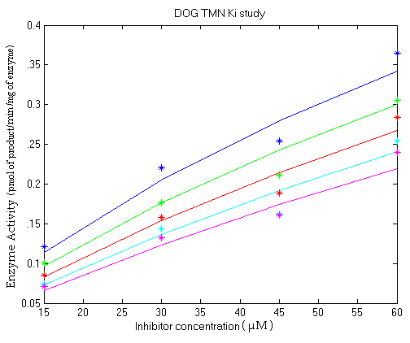Figure 9: In the figure, the points represent the experimental measurements while the curves represent the fit the predicted data.
________________________________________________________________________

The inhibitory potential of TMN against baboon liver MAO-B enzyme activity at concentrations of 0 µM, 2 µM, 4 µM, and 8 µM was tested. From these experimental results, Figure 10, baboon liver MAO-B enzyme was found to have a K_{i} value of 9.4 ± 1.8 µM.
________________________________________________________________________
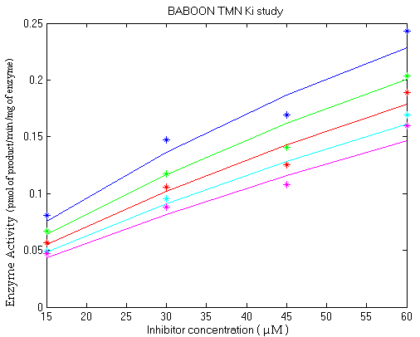Figure 10: In the figure, the points represent the experimental measurements while the curves represent the fit the predicted data.
________________________________________________________________________

The inhibitory potential of TMN against monkey liver MAO-B enzyme activity at concentrations of 0 µM, 2 µM, 4 µM, and 8 µM was tested. From the experimental results, Figure 11, monkey liver MAO-B enzyme was found to have an average K_{i} value of 10.3 ± 1.7 µM.
________________________________________________________________________
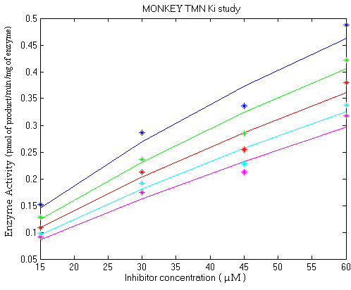Figure 11: In the figure, the points represent the experimental measurements while the curves represent the fit the predicted data.
________________________________________________________________________

The inhibitory potential of TMN against human liver MAO-B enzyme activity at concentrations of 0 µM, 2 µM, 4 µM, and 8 µM were tested. From the experiment, Figure 12, human liver MAO-B enzyme was found to have an average K_{i} value of 5.4 ± 0.4 µM.
________________________________________________________________________
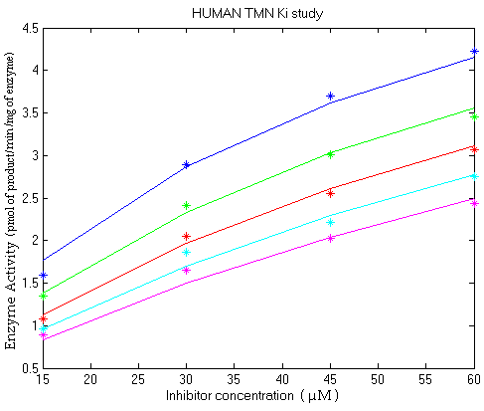Figure 12: In the figure, the points represent the experimental measurements while the curves represent the fit the predicted data.
________________________________________________________________________

Summaries of all the inhibition results are shown in Tables 3 and 4.

Table 3: CSC Inhibition Results

Table 4: TMN Inhibition Results

5. Discussion
Although the data for the TMN K_{i}’s are more accurate, as indicated by the standard error values being lower, CSC is a more effective inhibitor than the TMN compound, since the K_{i}’s of CSC are in the nM range while TMN inhibits MAO activity in the µM range. The higher errors found with the CSC studies could indicate that the inhibition occurs with a different mechanism than the competitive model. As the CSC and TMN have different inhibition constants, this also suggests that the inhibition mechanism might be different for the two compounds.
The variation in species trends of susceptibility to inhibition was an intriguing aspect of the results. Note, that the smaller the K_{i,} the stronger the inhibition effect. The monkey species had a K_{i} of 44 ± 20 nM with CSC while with TMN the K_{i} was 10.3 ± 1.7 µM. The K_{i} of the monkey species with CSC was the lowest in comparison to other species with TMN, however, the K_{i} was the highest of all the species. The human species had a K_{i} of 60 ± 24 nM with CSC while with TMN the K_{i} was 5.4 ± 0.4 µM. The K_{i} of the human species with CSC was one of the highest in comparison to the other species, but with TMN the K_{i} was the lowest of all the species. The baboon species had a K_{i} of 84 ± 32 nM with CSC while with TMN, the K_{i} was 9.4 ± 1.8 µM. The K_{i} of the baboon species with CSC and TMN was the highest in comparison to other species. The dog species had an insignificant K_{i} value with CSC while with TMN the K_{i} was 9.7 ± 1.8 µM. The CSC had a no inhibitory effect on the dog species while TMN the K_{i} was one of the lowest of all the species. The species vary when compared to one another in their susceptibility to CSC and TMN but even within the same species there was significant variation between CSC and TMN. From these findings there is a good indication that there are different interactions of between CSC and TMN and the active site of the MAO-B of the same species. A future study of inhibitor and MAO-B might be to study, in-silico, the differences in bonding interactions occurring among the species. Information obtained from such studies and the current study could help in developing a drug that effectively binds to and inhibits MAO-B as a treatment for Parkinson’s disease.

Acknowledgements

I would first like to thank the VCU Bioinformatics and Bioengineering Summer Institute for giving me the funding and one of the best opportunities. Also thank you to the individuals, Dr. Castagnoli and the graduates there, at Virginia Tech for supplying many of the compounds and enzymes and helping with my research during the academic year. Thanks to the individuals at the VCU Chemistry department, mainly Sarah Rutan and Ray Sanchez, for their aid in research and also for their facilities and materials. Lastly thanks for my fellow peers, for their support and the memories.

References

Anonymous. Parkinson's Disease Backgrounder. National Institute of Neurological Disorders and Stroke (NINDS). July 2001.

Binda, C., Newton-Vinson, P., Hubalek, F., Edmondson, D.E. and Mattevi, A. Structure of Human Monoamine Oxidase B, a Drug Target for the Treatment of Neurological Disorders. Nature, Structural Biology, 9, pp. 22-26, 2002.

Castagnoli, K., Murugesan, T. Tobacco Leaf, Smoke and Smoking, MAO Inhibitors, Parkinson’s Disease and Neuroprotection; Are There Links? Neuro Toxicology, 25, pp. 279-291, 2004.

Castagnoli, N., Dalvie, D., Kalgutkar, A., & Taylor, T. Interactions of Nitrogen Containing Xenobiotics with Monoamine Oxidase (MAO) Isozymes A and B: SAR Studies on MAO Substrates and Inhibitors. Chemical Research in Toxicology, 14 (9), pp. 1139 -1162, 2001.

Petzer, J.P., Steyn, S., Castagnoli, K.P., Chen, J., Schwarzschild, M.A., Van der Schyf, C.J. and Castagnoli, N. Inhibition of monoamine oxidase B by selective adenosine A2A receptor antagonists. Bioorganic & Medicinal Chemistry. Volume 11, Issue 7, April 2003, pp. 1299-1310.

Fowler, J.S., Volkow, N.D., Wang, G.J., Pappas, N., Logan, J., Shea C., et al. Brain Monoamine Oxidase Inhibition in Cigarette Smokers. Proc. Natl. Acad. Sci. U.S.A. 93 pp. 14065–14069, 1996.

Carr, L.A. and Basham, J.K. Effects of Tobacco Smoke Constituents on MPTP-Induced Toxicity and Monoamine Oxidase Activity in the Mouse Brain. Life Sci. 48, pp. 1173–1177, 1991.

Sanchez-Ponce, R. and Rutan, S. Steady State Kinetic Model Constraint for Multivariate Curve Resolution-Alternating Least Squares Analysis. Submitted to Chemometrics and Intelligent Laboratory Systems, 2004.

Norman, T.R., Chamberlain, K.G., and French, M.A. Platelet Monoamine Oxidase: Low Activity in Cigarette Smokers. Psychiatry Res. 20 pp. 199–205, 1987.

