E-Spinner

Josh Grant

Summer 2004

Prologue
At this point , the reader might take note of the additional prologue section of this paper. Although this paper will adhere as closely as possible to a traditional research paper, there will be instances where nontraditional formatting and language will be used due to the nontraditional nature of this project. First, it is important to point out that the device in question was suggested by Dr. Eugene Boland , Ph.D. Upon my arrival to Dr. Gary Bowlin’s lab in the Summer of 2004, I began work finishing this project. The mechanical framework was set, and the rotational axis (see introduction) was completed. The work completed my myself involved integrating both the hardware and software aspects of two additional axis of motion. The translation of the platform and the pitch of the mandrel both required precision control in order to aide reproducibility. In addition, testing was completed with the remaining time I had during the summer. A number of hardware setbacks were suffered during the Summer of 2004. In addition to hard drive failure and data loss on the computer driving the robot, two pieces of hardware critical to motion control failed.. With these setbacks, testing on the device was limited to the final week of the BBSI program.

Abstract
The use of nanoscale electrospun tissue scaffolding holds promise as a viable vector for tissue growth. By manipulating fiber characteristics, more viable scaffolding can be created. A robotic device was used to manipulate three different aspects of motion, mandrel rotation, platform translation, and pitch in order to better tailor a scaffold. Comparing SEMs, it is clear that pitch has an effect, but without further testing, no finite conclusion can be made.

Introduction

The use of artificially developed biodegradable cell scaffolding has only recently been considered. New developments in several disciplines have recently allowed further research in this subject. It is only through the integration of these disciplines that allow for the effective application of novel scaffolding. Past research has focused on one particular fabrication process for scaffolding known as electrospinning. Although this concept is not new, is not new, its mechanics and uses are only beginning to be understood. The physical basis of electrospinning revolves around two main principles, separation of charge and surface tension. In a typical apparatus, a syringe, filled with a polymer in solution, is set up so that the needle is subject to a large electric potential, on the order of 1 – 25 KeV. A grounded “target” is placed facing the syringe. Upon depressing the plunger of the syringe, a droplet is subjected to the electrostatic force generated between the tip of the needle of the syringe and the target. In the 1880’s , Lord Rayleigh determined that the stabilizing force on the droplet , tension T was related to the charge Q by the spherical radius a.
T > Q² / 16πa³ (1)
When this equation is made invalid due to a decreased radius or increased charge, liquid is thrown off in fine jets. In other words, when the electrostatic charge is larger than surface tension, liquid is thrown off in fine jets towards the grounded target.. As the solution is thrown off, it is propelled to the target and the solvent evaporates, leaving a pure polymer jet. Polymer strands collected on the target vary from micron to sub-micron in diameter. A diagram representing a typical electrospinning setup is shown below in Figure 1.
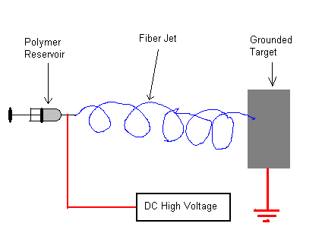
Figure 1. This figure is a schematically representation of a simple electrospinning setup.

Although this system does not seem complex, many variables can be altered yielding with dramatically different results. Altering the potential, polymer, polymer concentration, solvent, and mandrel distance to target all yield dramatically different results. In addition, mechanical manipulation of the target can dramatically change the way in which the fiber is collected. By varying the parameters above, radically different results can be achieved. By finding the right combination of variables, a more viable tissue scaffold can be forged.
Controlling the rotation, translation, and pitch of the target will allow for precisely crafted scaffolding for specific tissue growth. In particular, trajectories involving altered mandrel pitch have been suggested. By manipulating the pitch, fiber alignment can be controlled. Creating a device that allows for the manipulation of rotation, translation and pitch variables can pave the way for precisely engineered tissue scaffolds. In particular, custom blood vessel scaffolding can be created with such a device. Work completed prior to June 2004 on such a control system for the proposed device was completed by Dr. Eugene Boland , Ph.D.

Materials

Robot Hardware
Pitch Axis
- Applied Motion Products P/N HT17-075
- Superior Electric SS2000MD4 Stepper Drive
Rotational Axis
- MicroMo 1724T024SR Motor
- Micromo Drive
Translational Axis
- Parker Gemini GT stepper Drive
- OS22B-FLY0 Stepper Motor
- Parker 50 pin high density to flying leads cable
- 2 x Class RK5 Time Delay Fuses 10 Amp at 250VAC
Motion Control
- National Instruments 7344 Motion Control Interface
- National Instruments UMI 7764 Universal Motion Control Interface
- National Instrument SH68-C68-S Cable to connect 7344 to 7764
- National Instrument PCI-232/4 RS232, 4-Port Interface
Power Supplies
- Condor InternationalPlus Series HA5-1.5-OV-A+ 5 Volt 1.5 Amp Power Supply

Robot Software
Motion Control
- National Instruments Labview 6.1
- National Instruments Motion Assist
- Measurement and Automation Explorer (MAX)

General Connectivity
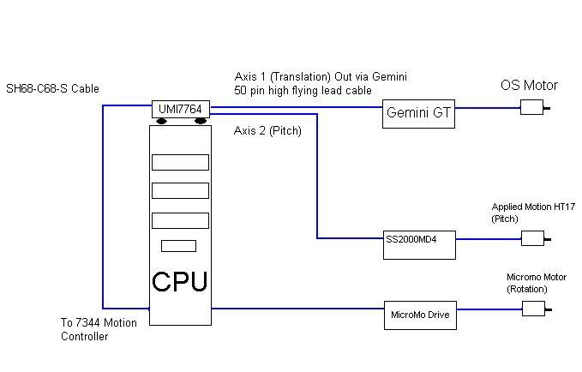
Figure 2 : This figure shows the general hardware connectivity of the ESpinner. The CPU drives the pitch axis and translational axis through the PCI-7344 and UMI-7644 interface. The rotational axis is driven through a serial RS-232 communication port. Each axis is driven by its own drive.

Specific Connectivity

Rotational Connectivity
This axis will not be discussed in this paper, as it was developed prior to the Summer of 2004.

Translational Connectivity
Translation is controlled through the National Instruments 7344 controller and UMI-7764 universal motion interface box. Steps are sent from Labview through the controller and universal motion interface to the Parker Gemini GT stepper drive. Connectivity between the UMI and the Gemini GT is established through a Parker 50 pin to high density cable. Only two wires are required from the UMI 7344 controller. First, the Step+ line from the Gemini (pin 8, black color wire) is connected to the STEP terminal on the UMI-7764. Second, the Dir line (pin 10 , red color wire) is connected to the DIR terminal on the UMI-7764.
Power is distributed to the Gemini GT through 2 UL class RK5 Time Delay Fuses rated for 10 amps at 250 VAC. The power distribution setup is located beneath the device. The Parker OS22B-FLY0 Stepper Motor was connected in a parallel configuration. The configuration is as shown below in Figure 1. It was determined that parallel connectivity provided maximum torque.
 | Drive Terminal | Motor Wire
Phase A
 | A+ | Red & Blue
 | A- | Yellow & Black
Phase B
 | B+ | White & Brown
 | B- | Orange & Green
Figure 3 : This figure shows the connectivity between the Parker OS22B stepper motor and a Parker Gemini GT-L5/6 Drive
In order to program the device, a null modem cable was used to connect to the drive’s RS-232 port. Using Parker’s Motion Planner Software, the drive was configured with default values for a Parker OS22B-FLY0 Stepper Motor wired in Parallel. After successful communication, the drive was issued a DMODE13 command through the Motion Planner Terminal to verify flashing of the EEPROM. DMODE 13 configures the drive to run in autorun mode, in which the motor runs at 1 rev/sec clockwise. After verifying proper function, a DMODE6 command was issued. This command enables the drive to receive step and direction commands from the National Instrument interface. The load on this axis is presumed to be constant, therefore altered performance is not expected with the collection of more mass (load) on the mandrel. This axis is therefore run as an open loop.

Pitch Connectivity
Much like the Translational Axis, the Pitch axis is also controlled through the National Instruments PCI-7344 and the UMI-7644. The pitch axis drive is a Superior Electric SS2000MD4 Stepper Drive. This drive requires three connections; like the translational axis, signals are sent via step and direction lines. Terminals marked 2 & 3 are line outs for pulse and direction respectively. These terminals both connect to the UMI’s step and direction. In addition, the Opto-Isolation line is connected to the +5 V terminal on axis 4 on the UMI-7644. The AWO terminal is left disconnected. AWO will disengage current to the motor when no signal is sent. This is not preferable, without current, no torque will be applied to the shaft, and the mandrel will not be held level.
Drive Connection | Drive Terminal # | Wire Color | UMI-7644 Terminal
Opto-Isolation | 1 | RED | +5 Volts
Pulse | 2 |  | Step
DIR | 3 |  | Direction
Figure 4: The connection of each required line of the pitch axis drive to the UMI-7644 is shown above. Step and Direction (or pulse and DIR) are required, in addition to a +5V reference line.
The motor and power supply connections are located on the same terminal strip. Power is supplied from the condor 24 V power supply. The motor is connected as
The drive is not setup via software like the translational drive, this drive is entirely jumper based. Two settings need to be taken into account. First, the resolution of the drive must be set. The default value is 200 steps/rev , however, in order to increase the precision of the device, the value was changed to 400 steps/rev. This was changed by changing switch #8 to on from the default off position. Next, the drive current must be set. This level was determined based on literature torque vs. speed curves. In this case, the switch at position 1 is set to on. The load on this axis is presumed to be constant, therefore altered performance is not expected with the collection of more mass (load) on the mandrel. This axis is therefore run as an open loop.

Software

This application demands precision and repeatability. In order to meet these demands, National Instrument’s Labview was used for the interface and control of motion. In order to ease the integration of motion control hardware, National Instruments’ Motion Assistant was used. This software predefines certain subroutines with 3rd party motion control product parameters. These subroutines, along with other functions are compiled in predefined subVis, much like a class or an object would be defined in another language. In addition, National Instruments’ MAX software was used to flash the flash memory of the PCI-7344 card.
Signals sent to both the pitch and translational axis are sent in the form of digital steps or counts. Both motors are stepper motors, so the signals can only be sent this way. The figure (4b) below outlines the concept of stepper logic. Direction line will indicate direction of shaft rotation, clockwise or counterclockwise depending on discrete line level (either 0 V or 5 V) . Steps sent will initialize actual movement. One step/pulse/count will move the shaft a fraction of a rotation. The fraction is based on the drive resolution.

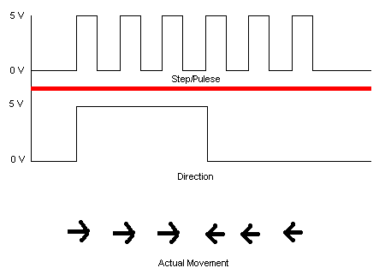
Figure 4b : The above represents the logic behind step/count signals. When the step/pulse line is high, the motor will count a step. Depending on the level of the direction line, the movement will either be clockwise or counterclockwise.

The user interface of the software designed to that the user can maintain control over each individual axis. Upon initializing the software, the user is prompted to log the specifics of their experiment. After logging the variables in designated fields, the parameters are saved to a text log file.
After saving the text file, the main control window opens, and the user is prompted to enter the specific operation parameters. The screen in figure 5 shows the main control screen. The input fields for mandrel velocity , translational displacement & velocity, and pitch angle and velocity. In addition, this panel also shows mandrel velocity feedback.
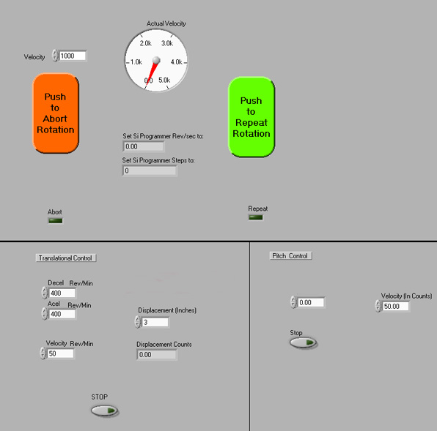
Figure 5 : This figure shows the control interface of the robot. The velocity of the mandrel is controlled in the top center control panel. The bottom left panel shows the velocity and displacement controls for the translational axis. The bottom right panel shows the pitch control.
This control setup allows ease of use through integration of each motion axis into one convenient window. Each axis can be individually stopped through the use of ratio buttons located on the panel.
The backend of the software is also controlled via labview. Labview allows for an ease of integration of both the front-end and back-end of the application. First, the motion interface parameters must be defined. These are completed through the objects in the blue box in figure 6. Here, acceleration, deceleration, velocity, and the address of the board are set. The large grey box represents a do while loop , after each motion trajectory initialized, the parameters are reread, so that real time modifications can be made. 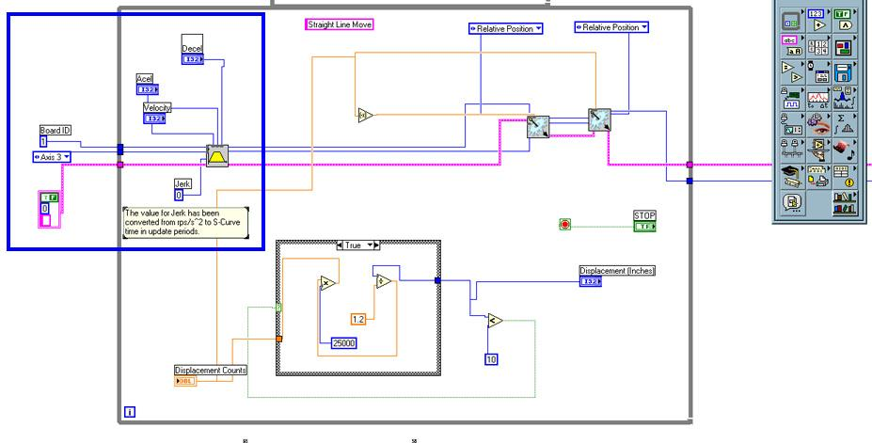

Figure 6: The blue box in this figure shows the definition of acceleration, deceleration, velocity and board address variables.

The motion is executed through two subVi located in the box below. These two calls make the platform move x steps in one direction, then x steps in the opposite direction. These subroutines are optimized for low latency so that there is no lag between iteration
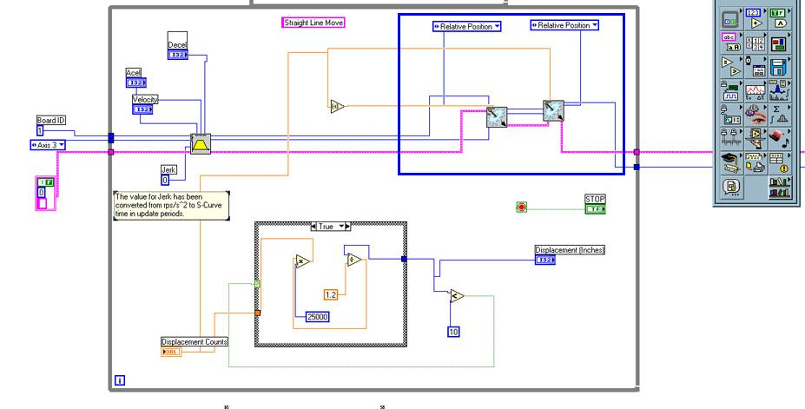
Figure 7: The box in this figure represents the subVi commands sent to the translational motor to make it move a predefined number of steps.

Finally, in order to prevent damage, a safety feature was integrated into the programming so that the device cannot translate further than the structure allows. By default, any displacement over 10 inches will be reverted back to 10 inches. This prevents potential damage to the system.
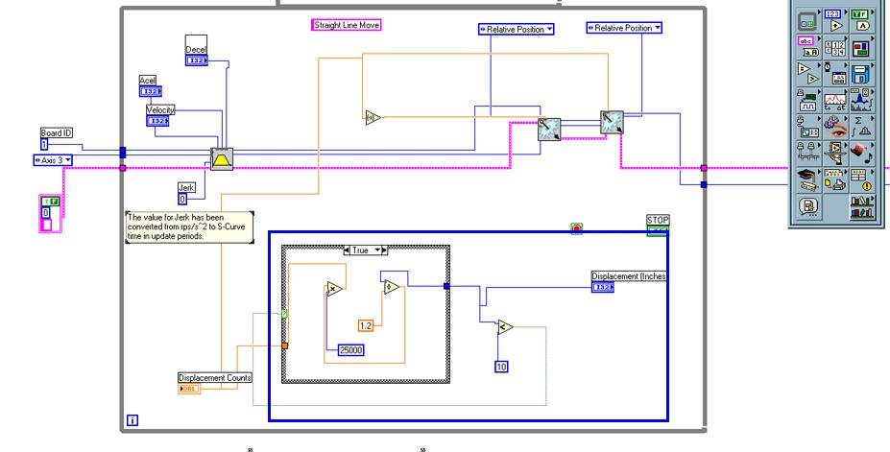
Figure 8: The objects in the blue box maintain a limit on the translational displacement.
In general , a similar setup is used for the pitch control. The control loop shown in figure 9 is used to control the pitch. The pitch axis uses four motion commands, rather than the two used in the translational axis. This is done to improve performance. The first motion command located in the blue box that it outside of the grey box in figure 9 is completed to provide an initial displacement, y, from the home position. The two motion commands in the blue box that is inside the grey box will alter the pitch between 2y and -2y. The final command is initiated once the loop is broken, and is located in the red box. This command returns the pitch to its home state by sending a displacement of
-y to the motor. Similar variable definition objects and safety structures are implemented in this control as well.

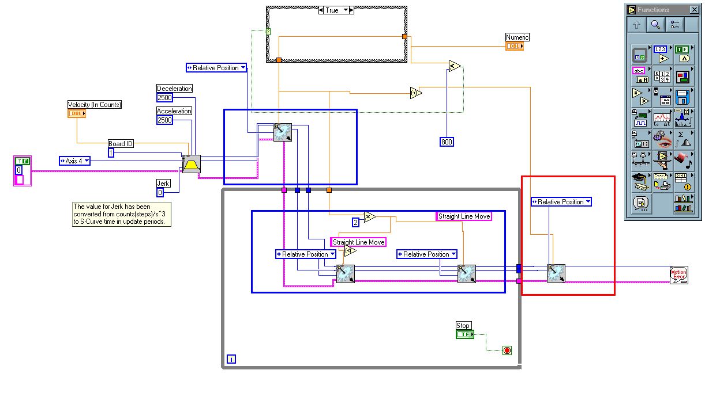
Figure 9: This figure shows the general pitch control. The blue and red boxes each show different motion

Both setups are located in the body of the main program. The flow of the program causes an initial pitch perturbation of y, a translation of x, a pitch perturbation of –y , and a translation of –x. This loop is repeated until the user stops the motion. The software is also set up so that each axis can be turned on or off during the experiment itself. This provides flexibility to the end user.

Methods

All materials and chemicals, unless otherwise noted, were provided by Dr. Bowlin at Virginia Commonwealth University. 3 ml samples were made by mixing a 1:10 ratio by weight of Poly Glycolic Acid (PGA, Alkermes, inc.) to 1,1,1,3,3,3-Hexafluoro-2-propanol (HFP , Sigma Aldrich Chemical) from original stock solutions. These solutions were loaded individually into Becton Dickinson 3.0 ml syringes and placed in a KD Scientific syringe pump. The pump was metered at a dispense rate of 10 ml/hr. The positive lead of a Spellman CZE1000R high voltage power supply was connected to the 18 gauge metal tip of the syringe, and a 22 KeV was applied. The Espinner was calibrated through software for each of the four trials. Table 1 shows the spin parameters for each trial.
Trial | Rotational Velocity | Translational Displacement | Translational Velocity | Pitch Velocity | Pitch Displacement
1 | 1800 RPM | 8 inches | 72 inches/min | 1500 counts/min | 0
2 | 1800 | 8 inches | 72 inches/min | 1500 counts/min | 200 counts
Table 1 : The above shows the parameters used in lab view for each trial.
Fibers were removed from the mandrel after completion of each trial run, samples were removed from the mandrel. Portions of each sample were sputter coated with a Electron Microscope Sciences model 550, and Scanning Electron Micrographs were taken using a JEOL JSM-820 JE electron microscope.

Results

Images acquired by electron microscope are shown below. Figure 10 shows trial 1, which is run with no pitch trajectory. Figure 2 shows the sample with 200 counts of pitch perturbation.
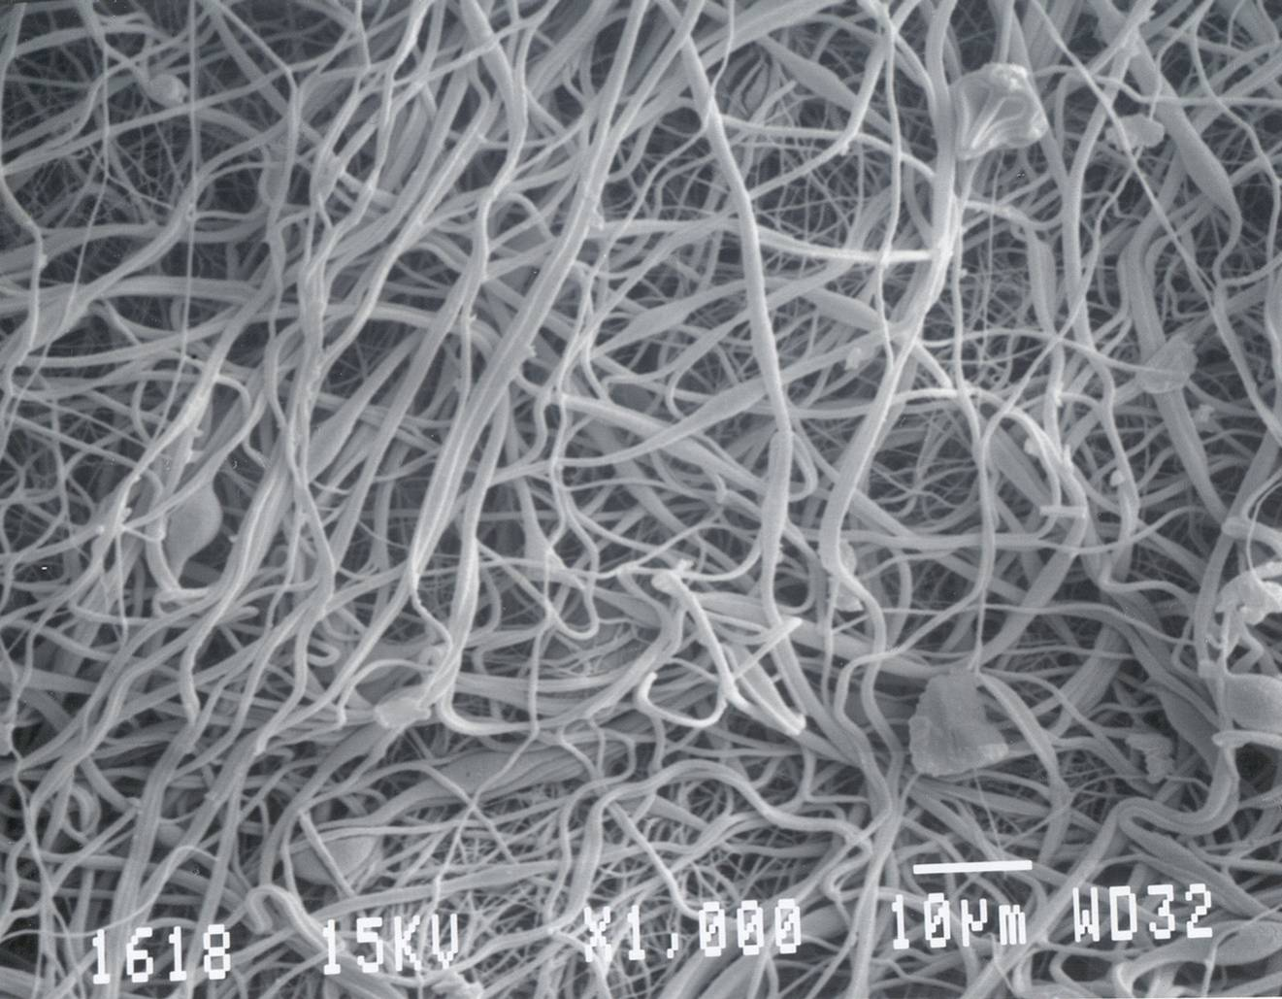
Figure 10: This figure shows the SEM of a 1:10 PGA in HFP solution spun without pitch.

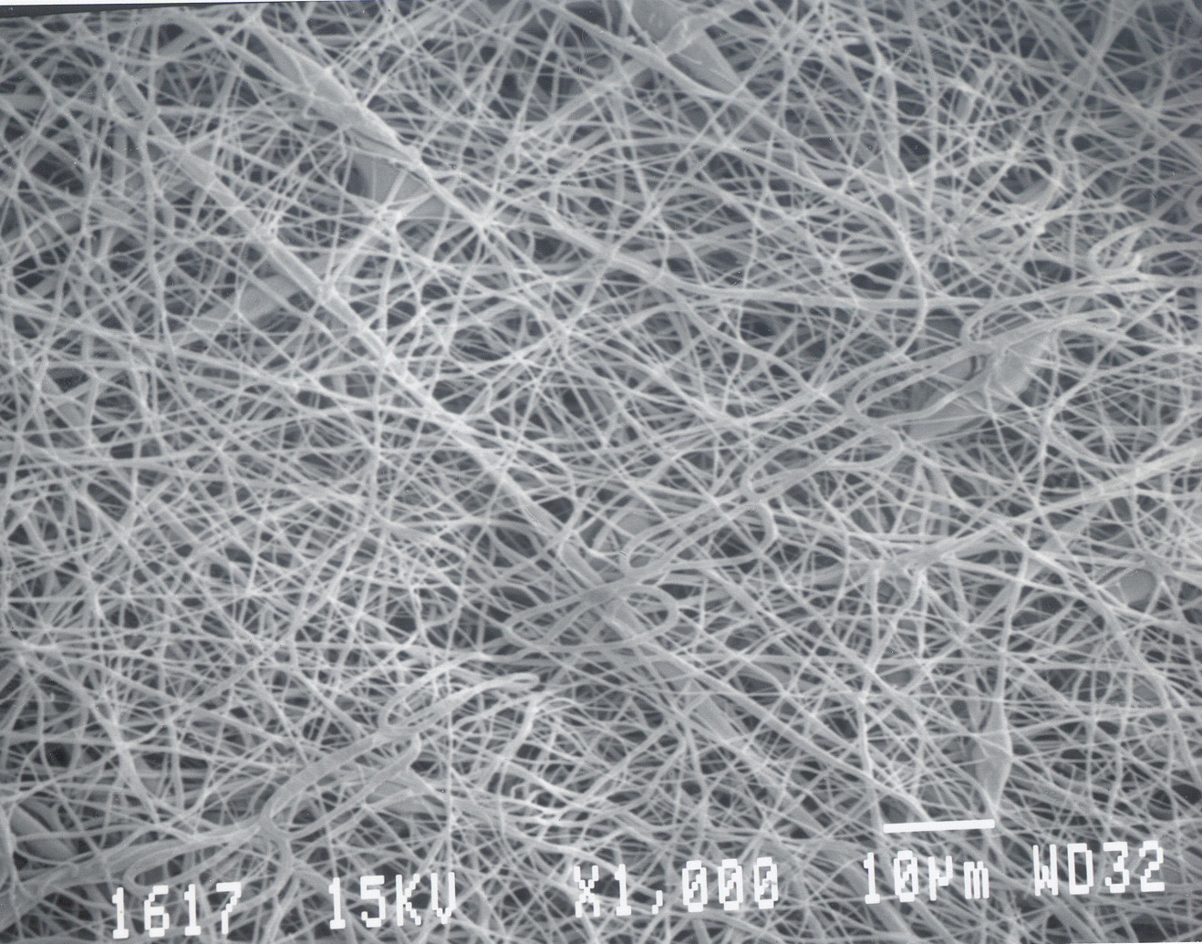
Figure 11: This figure shows the SEM of a 1:10 PGA in HFP solution spun with 200 count pitch.

Discussion

Manipulation of fiber alignment in addition to other fiber charecteristics was achieved in this experiment. By examining the SEMs taken , it is clear that pitch has a clear effect on fiber orientation, size and alignment. Figure 10 , which shows the sample without pitch appears amorphous. Observing figure 11, it is important to note the increased number of fibers which make perpendicular intersections with other fibers. This is indicative to some sort of ordering.
It is important to first point out that the results were obtained over the course of the final week of time of research. With the limited time available after the final completion of the robotic spinner, only a few samples could be run. Although these results should not in and of themselves represent definitive conclusions, they show drastic differences between the two samples. In order to verify the correlation, many more samples need to be analyzed, the sample size used in this experiment , one control and one variable, is by no means large enough to draw finite conclusions. I do however believe that more broad conclusions can be drawn.
In order to establish the validity of the above conclusions , it is obvious that more experiments with larger sample sizes must be completed. In addition , quantitative analysis of SEMs with image processing software would better characterize findings. Mechanical testing may also shed light on subtle differences between different pitch angles. Ultimately , seeding cells on spun matrices and determining compatibility characteristics will ultimately suggest how viable these samples are for tissue scaffolding. In particular, a collagen assay might be completed to determine the amount of cellular adhesion taking place.

Acknowledgements

I would first like to acknowledge the Bioinformatics and Bioengineering Summer Institute and Dr. Gary Bowlin for affording me the opportunity to work on this project. I would like to thank Eugene Boland for his support, as this is his old project. Without his expertise, I would not have progressed this far. I would also like to thank Catherine , Lindsey Denault, Andy Anderson , and Paul for their technical advice and support.

