Josh Grant

Introduction
The use of artificially developed biodegradable cell scaffolding has only recently been considered. New developments in a wide area of disciplines have recently allowed further research in this subject. It is only through the integration of these disciplines that allow for the effective application of novel scaffolding. Past research has focused on one particular fabrication process for scaffolding known as electrospinning. Although this concept is not new, is not new, its mechanics and uses are only beginning to be understood. The basis of electrospinning revolves around the understanding of charge separation and surface tension. In a typical apparatus, a syringe filled with a polymer in solution is set up so that the needle is subject to a fairly large electric potential, on the order of 1 – 10 KeV. A grounded “target” is placed facing the syringe. Upon dispersing the plunger of the syringe, a droplet subject to the electrostatic force generated between the tip of the needle of the syringe and the target. In the 1880’s , Lord Rayleigh determined that the stabilizing force on the droplet , tension T was related to the charge Q by the spherical radius a.
T > Q² / 16πa³ (1)
When this equation is invalid due a decreased radius or increased charge, liquid is thrown off in fine jets. As the liquid is thrown off, it is propelled to the target. As the polymer is thrown off , the solvent usually evaporates, leaving a pure polymer jet. Polymer stands collected on the target vary from micron to sub-micron diameter. A diagram representing a typical electrospinning setup is shown below in Figure 1.
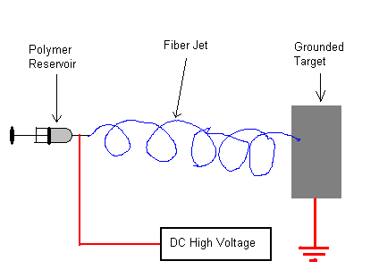
Figure 1. This figure is a schematically representation of a simple electrospinning setup.

Although this system does not seem complex, many variables can be altered with dramatically different results. Altering the potential, polymer, polymer concentration, solvent, and distance to target all yield dramatically different results. In addition, mechanical manipulation of the target can dramatically change the way in which the fiber is collected. By varying the parameters above, radically different results can be achieved. By finding the right combination of variables, a successful tissue scaffold can be formed.
This summers research will focus on two aspects of electrospinning. The first project will focus on the mechanical manipulation of the target in order to better control the formation of the scaffolding. Controlling the rotation, translation, and pitch of the target will allow for precisely crafted scaffolding for specific tissue growth. In particular, custom blood vessel scaffolding can be created with such a device. Previous work completed by Dr. Eugene Boland in Dr. Bowlin’s Lab will be continued developing such a system The second aspect of electrospinning that will be studied will be the characterization of different polymer mixtures. Polymers considered for this include fibrinogen, polyhydroxybutyrate, and polyglycolic acid.

