Abstract:
According to guanidinium chloride denaturation experiments, the binding affinity of the N-terminal (RNA recognition motif) RRM in the U1A RNA binding protein to stem loop two of U1 snRNA suffers a 5.5 kcal/mol destabilization upon mutation of the native phenylalanine 56 residue to alanine (F56A)¹. In order to characterize the type of interaction that causes this destabilization, the crystal structure of the F56A mutant U1A protein must be solved. Molecular dynamics (MD) simulations² predict that approximately 80% of the destabilization is due to the loss of stacking interactions and the remaining loss is due to U1A adaptation. Analysis of an accurate crystal structure will validate or refute this prediction. The results thus far reflect the attempt to clone and characterize the U1A protein needed to grow diffraction quality crystals.

Introduction:
The U1A RNA binding protein contains both an N-terminal and a C-terminal RRM but only the N-terminal function has been characterized. The N-terminal RRM of U1A binds stem loop two of U1 snRNA with a native k_{d} = 5(±2) x 10⁻¹⁰ M and ∆G = -12.7 ± 0.3 kcal/mol. Mutation of the Phe56 residue to alanine results in a mutant k_{d} = 5(±3) x 10⁻⁶ M and ∆G = -7.2 ± 0.3 kcal/mol which is a five fold destabilization in binding affinity¹. Investigation of the native crystal structure of the U1A-U1snRNA complex reveals aromatic stacking interactions between Phe56/Tyr13 and Phe56/A6 (position 6 in stem loop two of U1 snRNA). In silico studies predict that the main source of binding destabilization (~80%) in the Phe56Ala mutant is due to the loss of these stacking interactions. The remaining 20% has been attributed to unfavorable interactions arising from adjustments made by the U1A protein to accommodate the mutation at the binding site. Only a detailed crystal structure of the Phe56Ala mutant U1 snRNA complex will provide the experimental evidence needed to substantiate the in silico model.
In order to obtain the protein needed for crystallization, the correct genomic sequence must be ligated onto a vector that can express that sequence in a controlled manner. Although a 101 amino acid peptide was used in binding studies¹, only a 98 amino acid peptide was used during crystallization. The final peptide used to grow crystals also contained two structural mutations Y31H and Q36R (hereby referred to as the double mutant)³. These mutations were tolerated due to the fact that these mutations afforded higher quality crystals. In the interest of crystallizing the F56A mutant in a similar fashion to the double mutant (to save time in the screening process), all three mutations will be incorporated into a 98 amino acid sequence.
The plasmid supplied by Nagai contained a truly native 98 amino acid sequence, so all three mutations had to be engineered into the plasmid. The Nagai plasmid also lacked an easy method of purification (such as a poly histidine tag), so the 98 amino acid insert had to be cut out of the Nagai plasmid and ligated into a plasmid encoding a his-tag. Both the ligation of the U1A insert into a new plasmid and the mutagenesis used to introduce the necessary mutations involve molecular cloning techniques utilizing Polymerase Chain Reaction (PCR). Purifying the his-tagged protein involves the use of a Ni2+ chelating column. Currently we have obtained pure double mutant U1A, but due to a problem intrinsic to the plasmid used to create the F56A mutant, no F56A protein has yet been purified.
Materials and Methods:
Primer Construction to Amplify U1A Insert from Nagai Plasmid:
Any insert that is going to be ligated into a different plasmid must contain restriction sites on either side of the insert. Primers can be constructed that engineer any restriction site at the ends of an insert. The only considerations that must be put into the choice of restriction site is the cost or availability of the restriction enzyme, and whether or not that restriction site is present in the multi-cloning region of the target plasmid. NdeI (CATATG) and BamHI (GGATCC) were used to flank the U1A insert because these restriction enzymes were already in stock in the laboratory. Amplifying insert only is a little complex because during the first cycle of PCR, the restriction site itself does not bind to the single stranded DNA, but during the second rounds and onward, the restriction site does bind to the single stranded insert, effectively increasing the annealing temperature (T_{m}) of the primers. It is therefore necessary to develop primers that are capable of binding under both conditions.
Unlike mutagenesis primers, PCR primers have two points of origin at either end of the insert, so two primers must be developed for each end of the insert. Each restriction enzyme has a minimum number of nucleotides that should precede the restriction sequence to aid in efficient binding of the primers. The total primer length should be greater than twenty and less than fifty (often the GC% and T_{m} targets will help to determine the length of the primer). The target T_{m} for the first cycle of PCR is approximately 54°C and the target for the later rounds is 64°C. The GC% of the primers in all of the PCR cycles should remain above 30%. Be careful not to develop palindromes at the ends of primers because the primers will bind to themselves instead of the genomic DNA. Using these guidelines, the following PCR primers were developed:
The GC% and T_{m} are presented in the order of first round/later rounds. . .

5’-GGATTACCATATGGCAGTTCCCGAGACC-3`
GC% = 57.1% / 53.6% T_{m} = 58.5°C / 63.7°C n = 21 / 28

5`-CGCGGATCCTTACTATTTCATCTTGGCAATGATATCTGAG-3`
GC% = 37.8% / 42.5% T_{m} = 55.0°C / 65.6°C n = 37 / 40
****Note: The GC% and Tm calculations here DO include the restriction site (in bold), but the correct calculations should NOT contain the restriction site, only the nucleotides after the restriction site. Still, with these calculations the primers worked, so this may not be a crucial error. The Tm of each primer was calculated from the tools at www.idtdna.com.****

Transformation of Nagai plasmid into XL-1 Blue Cells:
XL-1 Blue cells are a strain of E. coli commonly used to produce plasmid to use for ligation or mutagenesis. XL-1 Blue cells contain no extra plasmids and therefore should not produce any contaminating DNA when purified using a plasmid purification kit. Newly transformed cells are plated on agar containing an appropriate selective antibiotic to screen for colonies which have absorbed plasmid. Since the genes conferring resistance to the selective antibiotic (usually ampicillin) are located on the plasmid, any bacterial colonies appearing on the plates should contain the desired plasmid. The protocol for the transformation into XL-1 Blue cells is located in the Protocols section.

Overnights:
Overnights are small preparations of cells used to purify plasmid or to inoculate a larger volume of media when producing protein. The protocol for overnights is located in the Protocols section. Overnights used for minipreps require no selective antibiotic, but overnights used to inoculate protein cultures must contain selective antibiotics.

PCR to Amplify the U1A insert from the Nagai Plasmid:
A miniprep was performed on an overnight of XL-1 Blue cells containing the Nagai plasmid to purify the Nagai plasmid for PCR. The VENT enzyme was used to amplify the U1A insert because it is a highly faithful polymerase. The recipe for the PCR mixture is located in the Protocols section.
First cycle |----------------------x5----------------------|
Temperature °C | 95 | 95 | 50 | 72
Time | 1:30 min | 1 min | 1 min | 1 min

Second cycle |----------------------x25----------------------|
Temperature °C | 95 | 60 | 72
Time | 1 min | 1 min | 1 min
The PCR is heated at 72°C for 6 minutes as a polishing step.

Restriction Digest of PCR DNA and the pET14b plasmid:
The resulting PCR DNA and purified pET14b plasmid was digested by restriction enzymes which were engineered onto the U1A insert (NdeI and BamHI). The protocol for the restriction digests is located in the Protocols section. 5µl of digested sample was run on a 0.8% agarose gel to determine purity.

Ligation of the U1A insert from the Nagai plasmid into pET14b:
Following a restriction digest of the PCR DNA and the pET14b plasmid with NdeI and BamHI, the two products were mixed together with T4 DNA ligase in order to ligate the U1A insert into the pET14b plasmid to aid in protein purification. The protocol for ligation is located in the Protocols section.

Transformation of pET14b Containing the U1A insert into XL-1 Blue:
The XL-1 Blue strain is known for high transformation efficiency, and for experiments with low success ratios (like ligation), a high transformation efficiency is preferable to transforming directly into a protein expression strain like BL21 or HMS174. The protocol is located in the Protocols section.

Screening for a Successful Ligation:
Now comes the hard part, actually getting the ligation to work. The transformed cells were plated onto LB agar plates containing ampicillin. Since the pET14b plasmid encodes for resistance to ampicillin, any cell colony containing the pET14b plasmid will survive and grow. Each colony must be grown in an overnight, followed by a miniprep to extract the plasmid, followed by a restriction digest, followed by running the digested DNA on an agarose gel to determine whether that colony contained plasmid with the U1A insert. Fortunately, only 10-15 colonies need to be screened simultaneously to determine whether or not the ligation was successful. If there are no inserts contained in any of the colonies, the ligation should be attempted again. That being said, it is not uncommon to perform 10-20 or more ligations before finding a colony with the correct insert. Sometimes it is necessary to redo the PCR if ligations are continually unsuccessful.

Gel Purification:
While gel purification of the PCR insert is by no means a theoretically necessary step in creating a successful ligation, I found that the ligation efficiency was enhanced using gel purified U1A insert. Gel Purification was done according to QIAEX II Agarose Gel Extraction Protocol, using water in step 9.

Primer Construction for Y31H/Q36R and F56A:
The most reliable primers for mutagenesis have a GC content > 30% and a relatively high melting temperature (T_{m} ~ 78°C). Additionally, codons that appear in less than 5% of the translated genome of the host organism (in this case E. coli) should be avoided if at all possible. Generally, it is preferable to change two nucleotides on a primer that encodes a frequently used codon than to change one nucleotide that encodes a rarely used codon. There should be at least 10 nucleotides on either side of the mutated nucleotides, but the total primer length should not exceed 50 nucleotides in length. Preferably the 3’ and 5` ends of the primer should be flanked by one or more G or C nucleotides. Tm is calculated by the equation T_{m} = 81.5 + (0.41*GC%) – (675 / n) – %mismatch (GC% = the number of C and G bases in the primer divided by the total number of bases multiplied by 100, n = the total number of nucleotides, %mismatch = number of nucleotides altered divided by the total number of nucleotides multiplied by 100). Based on this criteria, the following primers were developed:

Y31H and Q36R (TAC → CAC and CAG → CGC)
5`-GTCCCTGCACGCCATCTTCTCCCGCTTTGGCCAG-3`
GC% = 64.7% T_{m} = 79.3°C n = 34

F56A (TTT → GCT)
5`-GGGCCAGGCCGCTGTCATCTTCAAGGAGG-3`
GC% = 65.5% T_{m} = 78.2°C n = 29

Mutagenesis Formation of the Y31H/Q36R Double Mutant:
Since both the Y31H and Q36R mutations were contained on a single primer, only one mutagenesis reaction was performed. Purified plasmid is amplified using the primers (both forward and reverse compliment) developed previously as a template to introduce mutation. The protocol for the preparation of the mutagenesis mixture is located in the protocols section. The correct temperature and number of cycles must be chosen in order to obtain a suitable amount of amplified plasmid. The cycle has a high temperature to melt apart the double stranded DNA to allow the primers access to anneal at a lower temperature, then, an enzyme dependent elongation temperature is used for a period of time specific to the length of the plasmid being amplified.
|----------------------x18----------------------|
Temperature °C | 95 | 95 | 55 | 68 | 4
Time | 30 s | 30 s | 1 min | 10 min | hold

At 95°C the double stranded DNA is melted. At 55°C, which is far below the primer Tm, the primers may anneal to the single stranded DNA. At 68°C the Pfu Turbo enzyme may amplify the two single strands of DNA thus doubling the number of plasmids from the previous cycle. The 10 min time at 68°C was chosen based on the fact that Pfu Turbo requires approximately 2 min to copy 1kb of plasmid. Since pET14b is a 4.6kb plasmid, the estimation of 10 min to copy the entire plasmid is appropriate. The reaction was run for 18 cycles, which is standard for mutagenesis involving three altered nucleotides. Generally the number of cycles required can be calculated as 14 + (#altered nucleotides – 1)*2.

DpnI Digest of the Mutagenesis Reaction:
At the end of a mutagenesis reaction, there is a fraction of non-mutated plasmid mixed with the mutated plasmid, which can be a hassle when selecting colonies later on. Performing a DpnI digest eliminates the “parental” non-mutated plasmids by taking advantage of the fact that the host E. coli strain contains DAM methylated DNA. Since the mutated plasmid was not grown in E. coli, but produced outside of the cell, the mutated plasmid is not DAM methylated. DpnI digests only DAM methylated DNA, so a mutagenesis reaction that has been DpnI digested is nearly guaranteed to contain only mutated plasmid. Protocol for the DpnI digest is located in the Protocols section. DpnI product is also useful to send out for sequencing because there are high concentrations of plasmid. Assuming the sequence of the insert is correct, DpnI digested plasmid may be transformed directly into a protein expression strain such as BL21 or HMS174, or back into XL-1 Blue to obtain plasmid with which to perform the next mutagenesis to create the F56A mutant.

Creating the F56A Mutant:
Starting from purified double mutant plasmid from XL-1 Blue, repeat the mutagenesis process described previously using the F56A primer instead of the double mutant primer. The project has picked back up at this point now that double mutant protein has been produced.

Protein Expression:
There are so many ways to express protein that it would be impossible to cover them all in the scope of this paper. Some things to try if protein is not being expressed include a protein induction profile (running crude whole cell samples through SDS-PAGE at different time points to see when the most protein is produced), inducing the cells with different amounts of IPTG, and growing the cells at a different (usually lower) temperatures. That being said, there is a standard protocol for expressing proteins on an IPTG inducible plasmid (like pET14b), and that protocol happens to work well for the double mutation.
The whole point of going through the painful ligation process is to make growing protein much easier. The pET14b plasmid has an IPTG inducible promoter as well as an engineered poly histidine tag to make protein purification easier. After the pET14b plasmid containing the U1A double mutation was transformed into a protein expression strain (BL21 and HMS174 work equally well), a colony of the transformation was grown in a 10ml overnight for 16-18 hours. It is always a good idea when trying to obtain protein for the first time to create a glycerol stock (see Protocols) of the cells used to grow protein, that way, it is possible to use the same cell stock repeatedly to reliably grow protein. The overnight was diluted 100 fold (10ml in a 1L preparation of LB media plus ampicillin at a concentration of 50mg/ml at a volume ratio of 1:1000 so 1ml ampicillin in 1L of LB volume). This 1L culture was grown to an O.D. 600 between 0.6 and 1.0 which usually took on the order of 4 hours, at which point the culture was induced with 1M IPTG at a volume ratio of 1:1000. The cell culture was spun down for 15 min at 5000 rpm (at 4°C) and could be stored in the freezer indefinitely or resuspended immediately for protein purification. For a complete characterization of protein production, a 1ml sample of cells should be saved prior to centrifugation to run through SDS-PAGE

Protein Purification:
The cell pellet was resuspended in lysis buffer at a volume ratio of 1:50 (all buffer ingredients are given in the Protocols section) and the cells were broken in a cell breaker (2 times through at a pressure above 15000 psi) although sonication is a viable option. The resulting cellular lysate is spun for 30 min at 16000 rpm (at 4°C) to separate soluble protein from insoluble protein and cellular debris. The soluble portion is passed through a Ni²⁺ chelating column with a 0.45 micron filter attached to avoid clogging the column. The column is washed with increasing concentrations of imidazole and the elution from each of the washes is collected to run through SDS-PAGE. Finally the protein is eluted at a high imidazole concentration (in the Protocols section) and collected in 1ml fractions (stored at -20°C in >10% glycerol) to run through SDS-PAGE (this is to avoid combining impure fractions with pure fractions). For the double mutant, lots of protein is produced in the soluble portion of the cellular lysate, and pure protein may be obtained in the elution fractions off of the Ni²⁺ chelating column. Hopefully, the F56A mutant will be purified just as easily.

Crystallization:
Our first attempts at crystallizing the F56A mutant will be according to Nagai³. If Nagai’s method does not apply to the F56A mutant protein-RNA complex, then other precipitants such as polyethylene glycol (PEG) will be employed to try to obtain diffraction quality crystals.

Results:
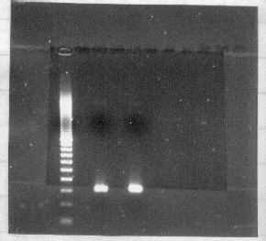
Figure 1.
0.8% agarose gel showing purified PCR insert from the Nagai plasmid. The presence of only one band indicates very pure insert, although gel purification is still recommended.
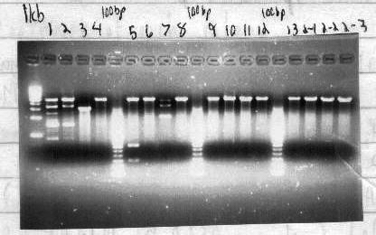

Figure 2.
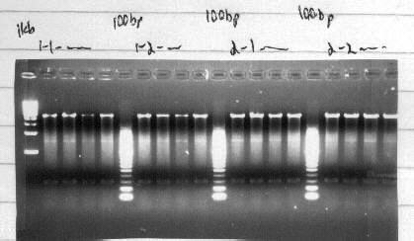
Lane 5 contains the 300 bp insert ligated into the pET14b plasmid. The 600bp insert is actually two copies of the same insert with a mutated restriction site in between.

Figure 3.
After gel purification, all of the colonies contained pET14b with a successfully ligated U1A insert around 300bp.

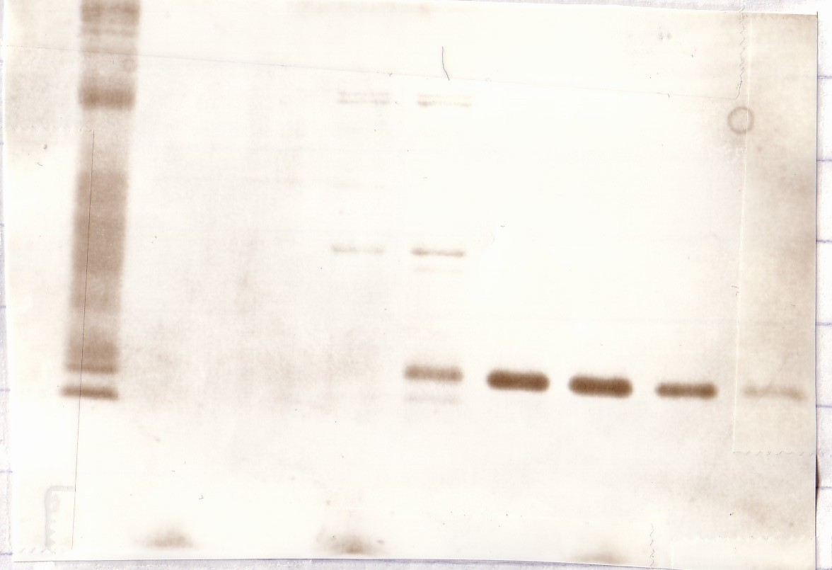
Figure 4.
Double mutant protein has been produced and purified over a Ni2+ chelating column. The elution fractions (right half of the gel) are very pure, which is very helpful when preparing protein for crystallization.

Discussion:
Unfortunately, there is not much to discuss as the problems encountered during the construction of the F56A mutant and the solutions to those problems have been presented in the methods section. As of yet, the 98 amino acid F56A mutant has yet to be produced, much less crystallized, due to a stall in the cloning process, during which time, most of my effort was focused on expressing another protein ErmB and crystallizing a third protein KSGA with adenosine. The stall occurred after obtaining the F56A mutation sequenced correctly in the pET14b plasmid. Every protein preparation produced protein that was four times too large. The reason for this has never been discovered although it is likely that something in the plasmid was causing transcription to occur beyond the two stop codons at the end of the insert (this has happened before in other protein preparations). After reviewing the notebook, it was discovered that there was still a stock of double mutant that successfully produced the correct size protein, although the plasmid was the wrong size when run on the gel. Obviously a smaller plasmid producing the right protein is better than a correctly sized plasmid that produces protein of the wrong size, so this plasmid will undergo mutagenesis to attempt to express the F56A mutant. Hopefully, the lessons learned during the cloning of the incorrect plasmid will speed up the time it takes to obtain the correct F56A mutant. From there, expression and crystallization should not be a problem; famous last words.

Protocols:
Transformations (everything should be on ice at all times)
+100 / 100 / 20 µl thawed XL-1 Blue, BL21 Gold, or HMS174 cells
+10 / 5 / 1 µl plasmid DNA from miniprep
Incubate on ice for 30 / 30 / 5 minutes
45 / 45 / 30 second heat shock at 42°C
Incubate on ice for 2 additional minutes
+0.9 / 0.9 ml LB / 80 µl SOC into a 15ml glass tube
+all of transformation into glass tube
Incubate at 37°C for 1 hour and plate 75-100 / 75 -100 / <50 µl on a LB + Ampicillin plate
****Note: Commercial competent cells normally use β-me in their protocol, always follow the protocol provided when using commercial products.****

Overnights
+Xml amount of LB (+10g Tryptone, +5g Yeast Extract, +10g NaCl per Liter)
+Xµl amount of 50mg/ml Ampicillin
+1 colony of bacteria on a sterile toothpick or pipette tip
Incubate at 37°C for 16-18 hours

PCR mixture
+83µl ddH₂O
+10µl 10x ThermoPol Buffer (for the VENT polymerase)
+2.0µl 10µM dNTP mix
+1.0µl 500µM Forward primer
+1.0µl 500µM Reverse primer
+2.5µl template DNA (unknown concentration)
+0.5µl VENT enzyme (1unit/100µl)

Restriction Digest of PCR Insert and pET14b Plasmid

 | PCR mixture | pET14b mixture
B2 | 6.0 | 1.0
BSA (10x) | 6.0 | 1.0
DNA | 46 | 2.0
NdeI | 1.0 | 0.5
BamHI | 1.0 | 0.5
ddH₂O |  | 5.0
 | 60µl | 10µl
Heat for 30 min at 37°C
+1µl SAP phosphatase to pET14b mixture to prevent premature ligation
Heat for 30 min at 37°C
Heat for 20 min at 80°C to deactivate SAP (proceed to Ligation)

DNA Ligation (everything should be on ice at all times)
+14.0µl ddH₂O
+2.0µl 10x T4 DNA Ligase Buffer
+0.5µl pET14b plasmid from digest
+2.5µl insert DNA from digest
+1.0µl T4 DNA Ligase
Incubate in a cold room in a floating H₂O bath at 14°C

Restriction Digest to Screen Plasmids from Minipreps

B2 | 1.0
BSA (10x) | 1.0
DNA | 5.0
NdeI | 0.5
BamHI | 0.5
ddH₂O | 2.0
 | 10µl
Heat for 1 hour at 37°C then add nucleic acid loading dye to stop the reaction

Mutagenesis (everything should be on ice at all times)

10x Pfu Buffer | 5.0
10mM dNTP mix | 1.0
Miniprep DNA | 0.5
Forward primer | 2.5
Reverse primer | 2.5
Pfu enzyme | 1.0
DMSO | 2.5
ddH₂O | 35
 | 50µl
Primers are resuspended to a 50ng/µl working concentration
DMSO seems to increase the transformation efficiency
****Note: Some PCR machines are not uniformly heated. As a result, evaporation changes the volume of mixture, which ruins the reaction. If the PCR machine does not have a heated lid, add 30µl of mineral oil to the top of the mutagenesis mixture. Make sure not to extract the mineral oil into the DpnI digest mixture.****

DpnI Digest of Mutagenesis Mixture
+2µl DpnI
+All of Mutagenesis
Heat for 1 hour at 37°C

Glycerol Stocks
+1ml bacterial cells
+0.5ml sterile glycerol
Store at -80°C

Buffers Used During Protein Purification
Lysis Buffer 50mM PO₄, 300mM NaCl, 10mM Imidazole, pH = 8.0
Wash 1 Buffer 50mM PO₄, 300mM NaCl, 20mM Imidazole, pH = 8.0
Wash 2 Buffer 50mM PO₄, 300mM NaCl, 50mM Imidazole, pH = 8.0
Elution Buffer 50mM PO₄, 300mM NaCl, 250mM Imidazole, pH = 8.0

To clean the column, the nickel is stripped with ~0.5M EDTA, washed with H₂0, then reloaded with 0.2M NiSO₄. 10ml of each buffer was run through the 5ml column. To prepare the column, 10ml of water to wash the free nickel, followed by 10ml of lysis buffer to equilibrate was passed over the column.

References:
1. Nolan, Scott J. et. al. “Recognition of an Essential Adenine at a Protein-RNA Interface: Comparison of the Contributions of Hydrogen Bonds and a Stacking Interaction.” J. Am. Chem. Soc. (1999) 121, 8951-8952.

2. Blackaj, Dukagjin et. al. “Molecular Dynamics and Thermodynamics of Protein-RNA Interactions: Mutation of a Conserved Aromatic Residue Modifies Stacking Interactions and Structural Adaptation in the U1A-Stem Loop 2 RNA Complex.” J. Am. Chem. Soc. (2001) 123, 2548-2551.

3. Oubridge, Chris et. al. “Crystallization of RNA-Protein Complexes II. The Application of Protein Engineering for Crystallization of the U1A Protein-RNA Complex.” J. Mol. Biol. (1995) 249, 409-423.

Extra Reading. . .
On ∆G measurements:
Katsamba, Phinikoula S., Myszka, David G., and Ite A. Laird-Offringa. “Two Functionally Distinct Steps Mediate High Affinity Binding of U1A protein to U1 Hairpin II RNA.” J. Biol. Chem. (2001) 276, 21476 – 21481.

On MD Simulations:
Tang, Yun and Lennart Nilsson. “Molecular Dynamics Simulations of the Complex between Human U1A Protein and Hairpin II of U1 Small Nuclear RNA and of Free RNA in Solution.” Biophysical Journal, (1999) 77, 1284-1305.

This project is funded by grants received from both the National Science Foundation (NSF) and the National Institutes of Health (NIH) awarded to the BBSI program at Virginia Commonwealth University.

